# PRACTICAL FILE

# OF

## “Practical Web Technologies”

**(BCA 175)**

submitted in the partial fulfillment of the requirement for the

award of degree of

#### **BACHELOR**

**OF**

#### Description: C:\Users\Administrator\Desktop\0.jpg**COMPUTER APPLICATIONS**

**SUBMITTED BY:BHAWYA GARG**

**Semester – 1**

**Shift – 1st**

**Batch:2021-2024**

**SUBMITTED TO: Dr . SONAL DAHIYA**

**DEPARTMENT OF COMPUTER APPLICATIONS**

**Practical-1**

**Objective:-** Make following five different web pages:

( i ) Formatting Styles and Headings: Include Bold, italics, Underline.

Source code:-

<!doctype html>

<html lang="en">

<head>

<title>Practical 1(i home page)</title>

</head>

<center><body background="C:\Users\Bhavya\Downloads\design-an-attractive-background-for-your-website.jpg" width="100%" height="100%">

<font color="goldenrod" size="8" face="algerian"><h1><u>HOME PAGE</u></h1></font>

<center><a href="http://www.google.com" target="_blank" color="white"><font color="lightsalmon">click here to go to the google home page</a></font></center> <font color="darkkhaki"><h2><i>This Is Italic</i></h2></font>

<h3><font color="violet" size="4"><u>This Is Underline</u></font></h3>

<font color="aqua" size="4"><h4><s>This Is Strike</s></h4></font>

<font color="coral" size="4"><h4>This is Superscript -->9<Sup>3</h4></font>

<font color="greenyellow" size="4"><h5>This Is Subscript --> made by<sub>bhawya garg<sub></h5></font></center>

<center><font size="6" color="gold"><B>TECNIA INSTITUTE OF ADVANCED STUDIES</b></font></center>

<p align="center"><font color="springgreen" size="3">1) PRACTICAL 1 LINKS:</font>

<a href="file:///C:/Users/Bhavya/Documents/wtptb.html" target="_blank"> <font color="springgreen">part (ii)</font></a>

<a href="file:///C:/Users/Bhavya/Documents/wtp1c.html" target="_blank"> <font color="springgreen">part (iii)</font></a>

<a href="file:///C:/Users/Bhavya/Documents/wtp1d.html" target="_blank"> <font color="springgreen">part (iv)</font></a><BR>

<a href="file:///C:/Users/Bhavya/Documents/wtp2.html" target="_blank" color="white"><font color="springgreen">2) LISTS</a></font><BR>

<a href="file:///C:/Users/Bhavya/Documents/wtp3.html" target="_blank" COLOR="WHITE"><font color="springgreen">3) TABLES</a></font><BR>

<a href="" target="_blank"><font color="springgreen">4) FRAMES</a></font><BR>

<a href="http://127.0.0.1:5500/image map.html" target="_blank" COLOR="WHITE"><font color="springgreen">5) IAMGE MAP</a></font><BR>

<a href="http://127.0.0.1:5500/forms.html" target="_blank" color="white"><font color="springgreen">6) FORMS</a></font><BR></p>

</body>

</html>

**output :-**

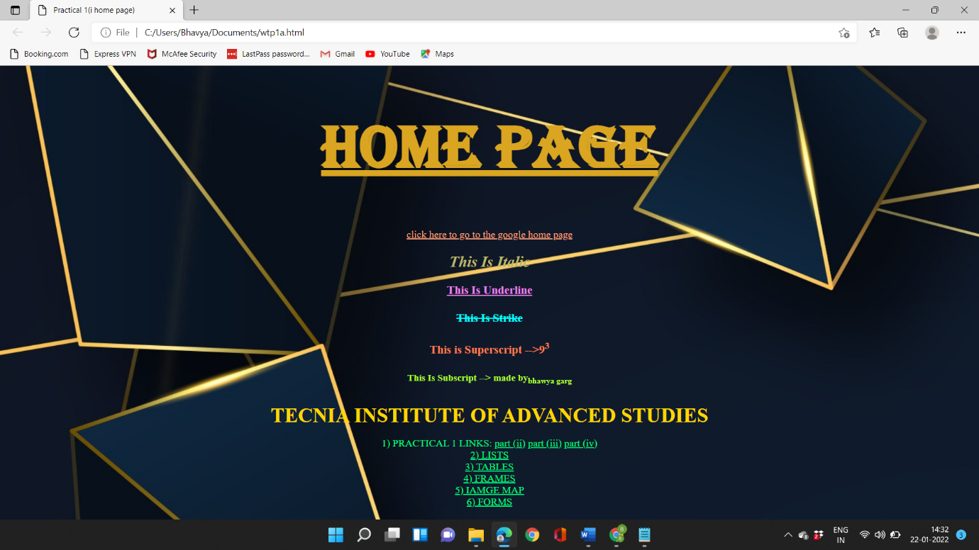

**( ii ). Font Styles and Image tag.**

**Source code:-**

<!DOCTYPE html>

<html lang="en">

<head>

<title>Practical 1(ii)</title>

</head>

<body bgcolor="midnightblue">

<a href="file:///C:/Users/Bhavya/Documents/wtp1a.html"><font color="yellow" size="3">home page </a></font>

<a href="file:///C:/Users/Bhavya/Documents/wtp1c.html"><font color="yellow" size="3">part (iii)</a></font>

<a href="file:///C:/Users/Bhavya/Documents/wtp1d.html"><font color="yellow" size="3">part (iv)</a></font>

<center>

<a href="https://www.google.com/"><font face="Curlz MT" color="goldenrod" size="6"><H1><b><u> STYLES AND IMAGE TAGS </u></b></H1></font></a>

<font face="Arial" color="lightseagreen"><h2 style="border:2px solid crimson;">This text is Arial</h2></font><br>

<font face="verdana" color="moccasin"><h3 style="border:2px solid rgb(255, 83, 71);">This text is written in 'verdana' font style</h3></font><br>

<font face="courier" color="khaki"><h4 style="border:2px solid yellow;"><b>This text is written in courier font style</b></h4></font><br>

<font face="M5 PGothic" color="cyan" size="4"><h5 style="border:2px solid darkorange;"><b>This text is written in 'MS PGothic' font style</b></h5></font><br>

<img src="C:\Users\Bhavya\Downloads\tias-logo.jpg" alt="TECNIA IMAGE" color="blue" weidth="100%" height="20%" border="10" style="border:10px solid gold;">

</center>

</body>

</html>

**Output:-**

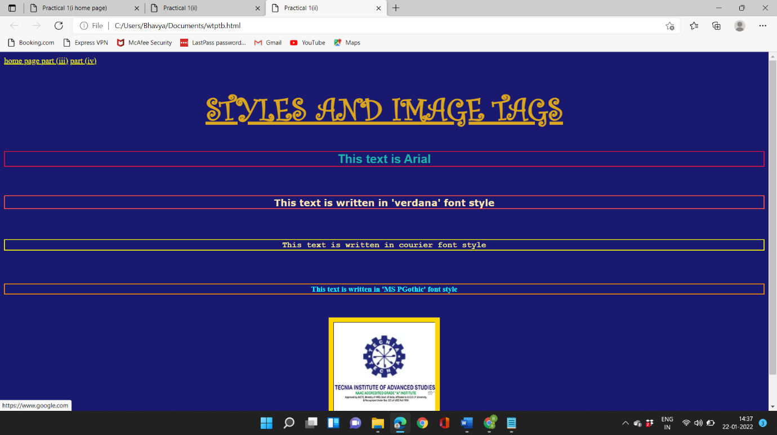

**( iii ). Marquee Move text, image and hyperlink.**

**Source code:-**

<!DOCTYPE html>

<html lang="en">

<head>

<title>Practical 1(iii)</title>

</head>

<body bgcolor="pink">

<a href="file:///C:/Users/Bhavya/Documents/wtp1a.html" target="_blank"><font color="maroon" size="4" face="French Script MT"><b>HOME PAGE</b></a></font> <a href="file:///C:/Users/Bhavya/Documents/wtptb.html" target="_blank"><font color="maroon" size="4" face="French Script MT"><b>part (ii)</b></a></font> <a href="file:///C:/Users/Bhavya/Documents/wtp1d.html" target="_blank"><font color="maroon" size="4" face="French Script MT"><b>part (iv)</b></a></font>

<center><a href="https://www.google.com/"><MARquee bgcolor="hotpink"><h2><font color="firebrick" face="Algerian"><b><u><i>MARQUEE, IMAGE AND HYPERLINK HTML TUTORIAL</a></i></u></b></font></h2></MARquee></center>

<center><img src="C:\Users\Bhavya\Downloads\bca.jpg" alt="BCA image" border="10" style="border:3px solid purple;"></center>

<center><font face="algerian" color="brown"><h2 color="brown"><b><u>LIST OF 1ST SEMESTER SUBJECTS</u></b></h2></center></font>

<marquee bgcolor="plum" direction="right" behaviour="alternate"><h3><font color="deeppink"><b>1.Technical communication</b></font></h3></marquee>

<marquee bgcolor="cyan" direction="left" behaviour="alternate"><h3><font color="hotpink"><b>2.Fundamentals of IT and computer</b></font></h3></marquee>

<marquee bgcolor="plum" direction="right" behaviour="alternate"><h3><font color="deeppink"><b>3.Discrete Mathematics</b></font></h3></marquee>

<marquee bgcolor="cyan" direction="left" behaviour="alternate"><h3><font color="hotpink"><b>4.Labs-IT, WT, CL</b></font></h3></marquee>

<marquee bgcolor="plum" direction="right", behaviour-"alternate"><h3><font color="deeppink"><b>5.web Technologies</b></font></h3></marquee>

<marquee bgcolor="cyan" direction="left" behaviour="alternate"><h3><font color="hotpink"><b> 6.PROGRAMMING using 'c' Language</b></font></h3></marquee>

</body>

</html>

**Output:-**

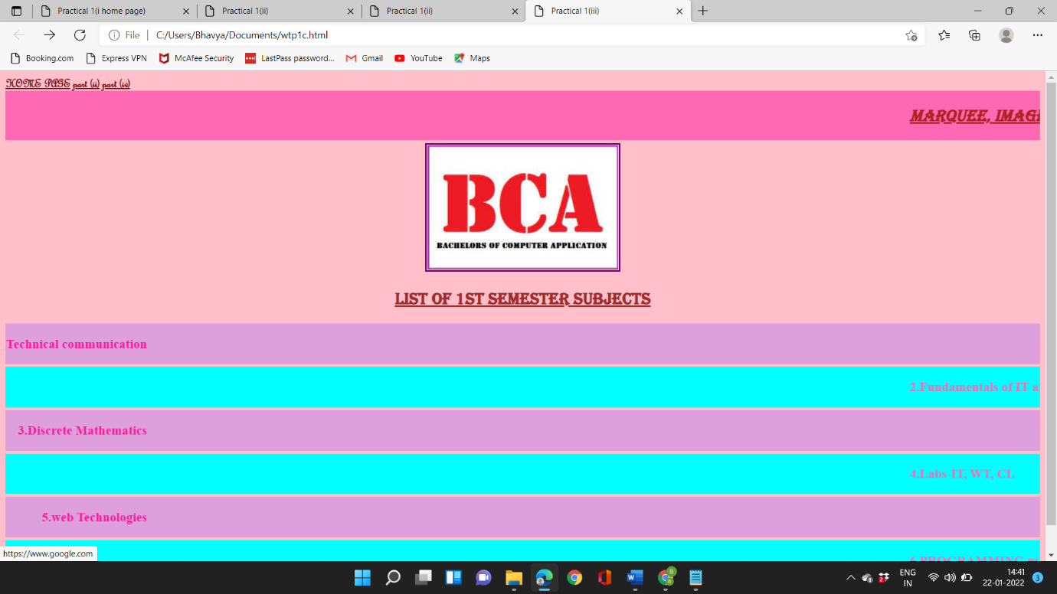

**( iv ). Other tags: BR, HR, pre, p**

**Source code:-**

<!DOCTYPE html>

<html lang="en">

<head>

<title>Practical 1(iv)</title>

</head>

<body bgcolor="lightgreen" border="10" style="border:10px solid red">

<p><font color="black" face="algerian"><a href="file:///C:/Users/Bhavya/Documents/wtp1a.html"><b> Home page</b></a></font></p>

<p><font color="black" face="algerian"><a href="file:///C:/Users/Bhavya/Documents/wtptb.html"><b> part (ii)</b></a></font></p>

<p><font color="black" face="algerian"><a href="file:///C:/Users/Bhavya/Documents/wtp1c.html"><b> part (iii)</b></a></font></p>

<center><a href="https://www.google.com/"><h1><u><font face="algerian" color="dark blue" size="6">OTHER TAGS</font></u></h1></a></center>

<br>

<center><h1>The blank spaced line above is added using 'BR tag. </h1></center>

<hr color="red">

<center><pre><b> <h2>Red line above is added by using 'hr' tag</b></h2></pre></center>

<center><pre><b> <h2>Line you are reading contains 'pre tag. 'Pre tag makes the element use only specified space.</b></h2></pre></center>

<center><p><h2><em>This line is emphasised with the use of em' tag.</em></h2></p> <p><h2><strong>This line strongly emphasised with the use of 'strong' tag.</strong></h2></p></center>

</body>

</html>

**Output:-**

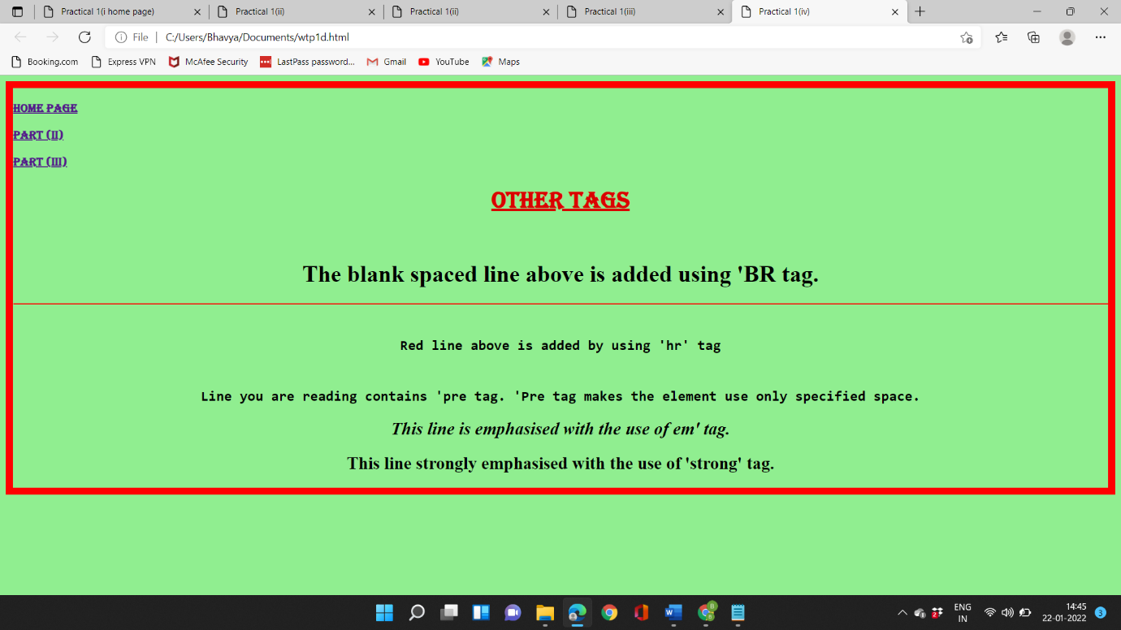

**Practical-2**

**Objective:-** Create an unordered list nested inside ordered list and apply the following:

* Insert an image of Main item on top right corner of web page.
* Display heading as a marquee.
* Use different font styles and colors for different ordered list items.
* Insert horizontal line after each ordered item.

SOURCE CODE:-

<!DOCTYPE html>

<html lang-en">

<head>

<title>Practical 2</title>

<head>

<body bgcolor="black">

<a href="file:///C:/Users/Bhavya/Documents/wtp1a.html" style="color: darkgrays "><font color="gold" face="Algerian"><b>HOME PAGE</b></font></a>

<center>

<img src="C:\Users\Bhavya\Downloads\bca.jpg" width="100" align="right" border="10" style="border:10px solid lightgreen">

<font face="Algerian">

<a href="https://www.google.com/font face algerian" size="5" ORDERED AND UNORDERED LISTS/H1></font></center><marquee behavior="1" direction="right"><h2 style="color: lightgreen;"><u><b>BCA SYLLABUS</u></b></h2></marquee></font>

<font color="yellow">

<ol>

<li style="color: lawngreen";">WEB TECHNOLOGIES</li>

<ul>

<li>unit-1:-world wide web , HTML overview</li>

<li>unit-2:-css , bootstrap basics</li>

<li>unit-3:-introduction to java script</li>

<li>unit-4:-XML, web hosting concepts</li>

</ul><hr color="snow">

<li style="color: lawngreen">DISCREATE MATHS</li>

<ul>

<li>unit-1:-sets , relation and functions , proportional logic.</li>

<li>unit-2:-partial order relation and lattices</li>

<li>unit-3:-combinatorics ,recurrence relation</li>

<li>unit-4:-graphs</li>

</ul><hr color="snow">

<li style="color: lawngreen">TECHNICAL COMMUNICATION</li>

<ul>

<li>unit-1:-Concepts and fundamentals</li>

<li>unit-2:-oral comunication</li>

<li>unit-3:-written communication</li>

<li>unit-4:-soft skill , language skills</li>

</ul><hr color="snow">

<li style="color: lawngreen">FUNDAMENTALS OFCOMPUTERS & IT</li>

<ul>

<li>unit-1:-fundametals of computers , computer hardware , computer memory</li>

<li>unit-2:- interaction with computers , computer software , operating systems , DOS , computer languages</li>

<li>unit-3:-computer number system ., binary airthmetics</li>

<li>unit-4:- computer network and internet , internet</li>

</ul><hr color="snow">

<li style="color: lawngreen">PROGRAMING USING 'C' LANGUAGE</li>

<ul>

<li>unit-1:-c-basics , c- control structures</li>

<li>unit-2:-c-functions , storage classes</li>

<li>unit-3:-structures , file handeling</li>

<li>unit-4:-standard library functions , usage of command line arrgument</li>

</ul><hr color="snow">

<li style="color:lawngreen">LABS</li>

<ul>

<li>CLab</li>

<li>IT Lab</li>

<li>WT Lab</li>

</ul><hr color="snow">

</ol>

</font>

</body>

</html>

Output:-

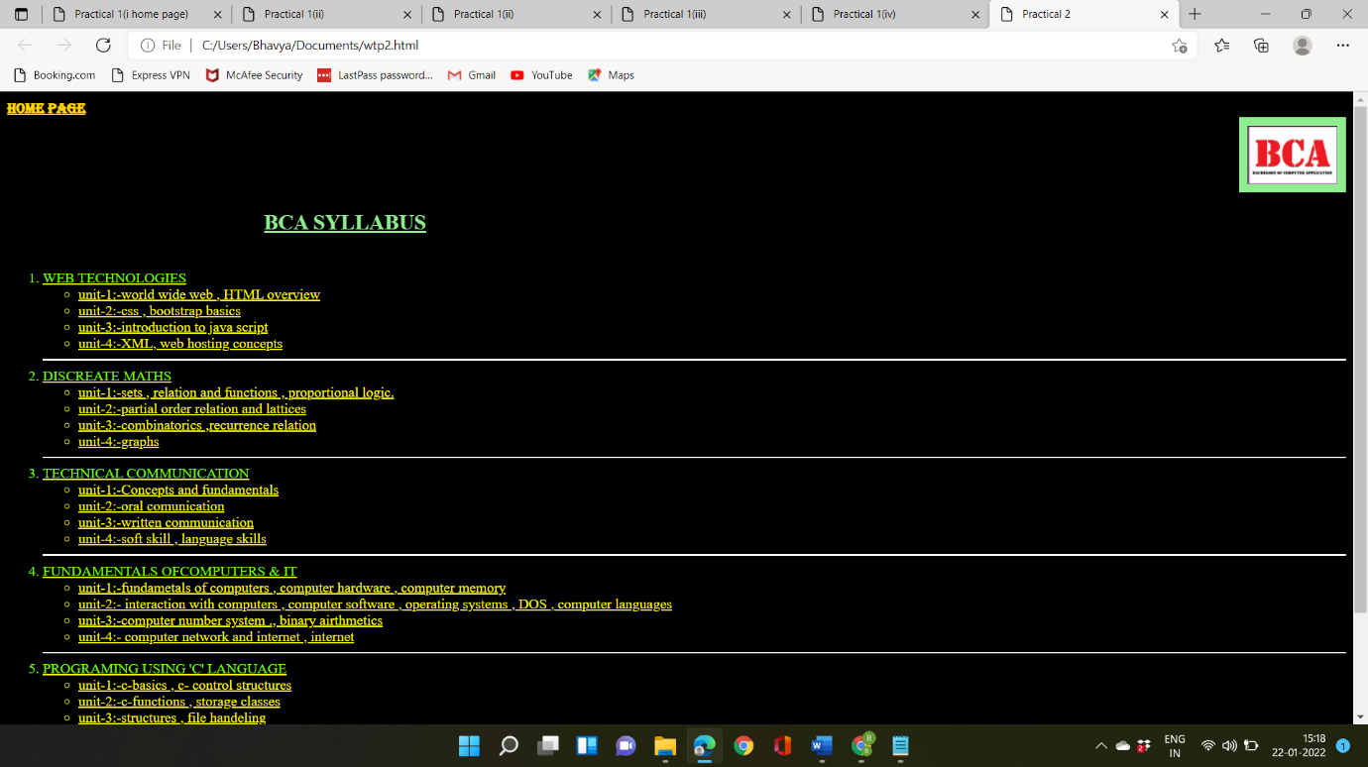

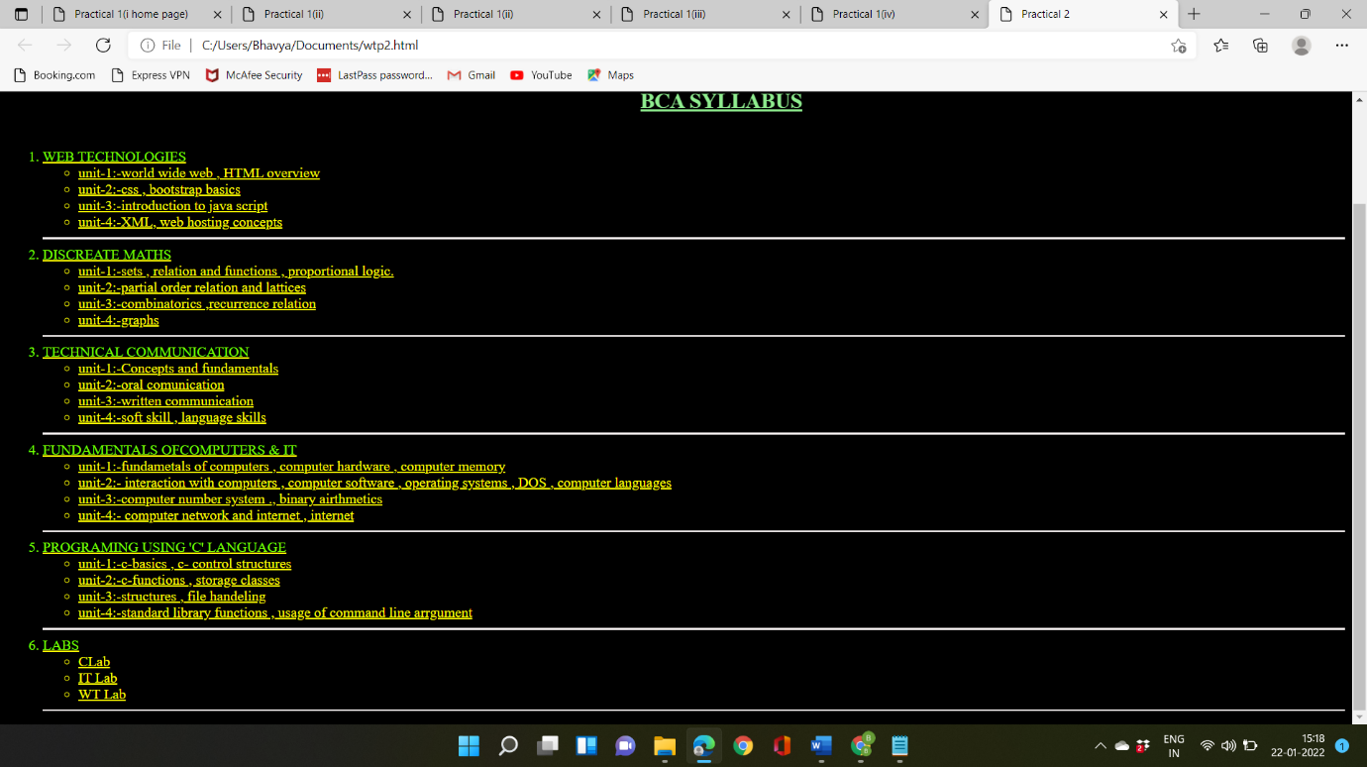

Practical-3

Objective:- Design a table with row span and column span and make use of attributes colspan, rowspan, width, height, cellpadding, cellspacing etc.

Source code:-

<!DOCTYPE html>

<html lang="en">

<head>

<title>Practical 3</title>

</head>

<body bgcolor="black">

<a href="http://127.0.0.1:5500/first code. html"><font color="deeppink">HOME PAGE</a></font>

<center><a href="https://www.google.com/"><font face="algerian" color="lightgreen"><h1><u><b>TABLES</h1></font></a><b></u></font>

<font color="black"> <table border="1" background="C:\Users\Bhavya\Downloads\b9ea4e526fb0fc0fd8038ac713fbb881.jpg" width="1000px" height="500px" breadth="500px" style="border:10px solid coral"><br>

<tr>

<th rowspan="2">NAME</th>

<th colspan="3">MARKS</th>

<th rowspan="2">TOTAL</th>

</tr>

<tr>

<th>ENGLISH</th>

<th>HINDI</th>

<th>IP</th>

</tr>

<tr>

<td>muskan</td>

<td>99</td>

<td>99</td>

<td>99</td>

<td>297</td>

</tr>

<tr>

<td>Himesh</td>

<td>99</td>

<td>99</td>

<td>99</td>

<td>297</td>

<tr> <td>khyati</td>

<td>99</td>

<td>99</td>

<td>99</td>

<td>297</td>

</tr>

<tr>

<td>ankush</td>

<td>99</td>

<td>99</td>

<td>99</td>

<td>297</td>

</tr>

</font>

</table></center>

</body>

</html>

Output:-

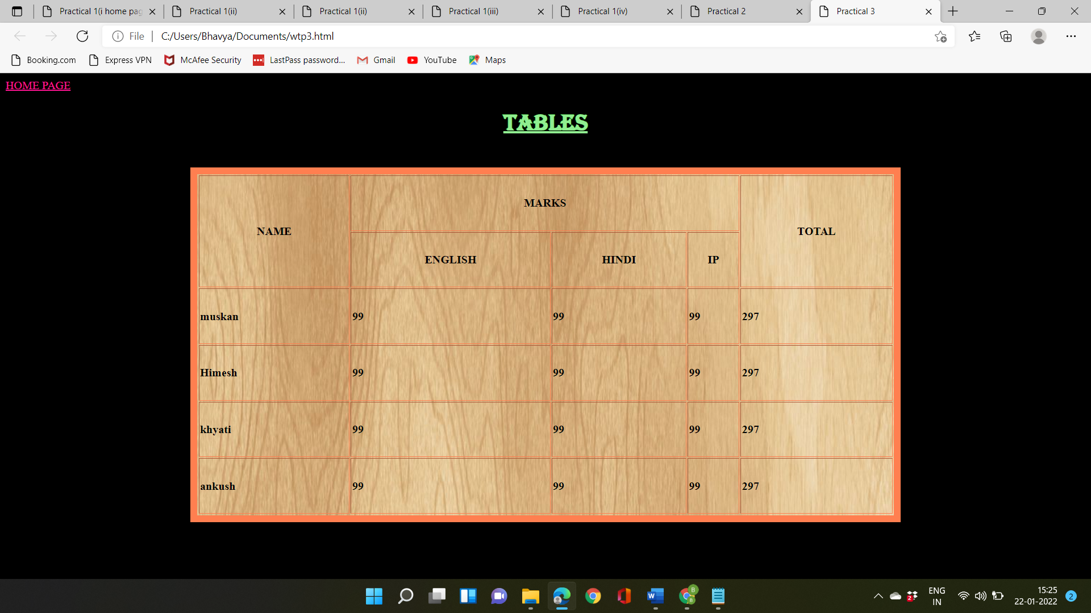

Practical-4

Objective:-Design following frame:-

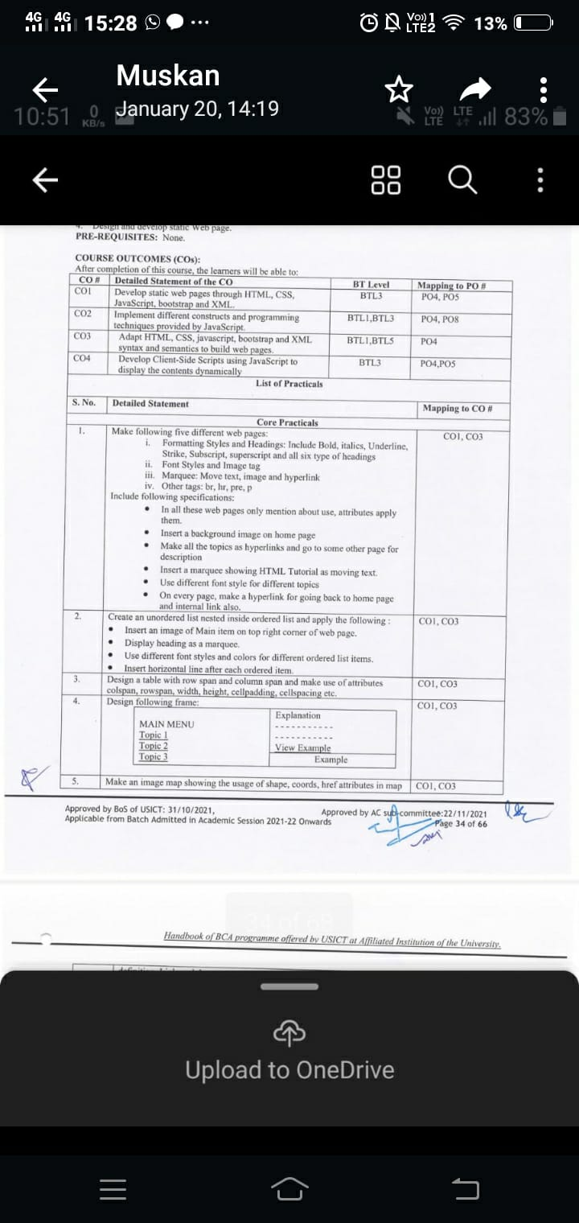

Source code:-

<!DOCTYPE HTML PUBLIC "-//W3C//DTD HTML 4.01 Frameset//EN"

"http://www.w3.org/TR/htm14/frameset.dtd">

<HTML>

<HEAD>

<TITLE>A simple frameset document</TITLE>

</HEAD> <FRAMESET rows="40%, 60%">

<FRAME src="file:///C:/Users/Bhavya/Desktop/BCA/web%20technologies/wtp4b.html">

<FRAMESET cols="50,50">

<FRAME name "bottomleft" src="file:///C:/Users/Bhavya/Desktop/BCA/web%20technologies/wtp4d.html">

<FRAME name="bottomright" src="">

</FRAMESET>

. .

<!DOCTYPE html>

<html lang="en">

<head>

<title>Practical 6(a)</title>

</head>

<body bgcolor="beige"><a href="file:///C:/Users/Bhavya/Documents/wtp1a.html">home page</a>

<ol>

<font face="algerian" color="brown" size="5"><h1><U><B>MAIN CONTENT</U></B></h1></font>

<font size="30">

<li><a href="file:///C:/Users/Bhavya/Desktop/BCA/web%20technologies/wtp4c.html" target="bottomleft"><b>GGSIPU </b></a></li><br>

<li><a href="file:///C:/Users/Bhavya/Desktop/BCA/web%20technologies/wtp4d.html" target="bottomleft"><b>tecnia </b></a></li><br>

<li><a href="file:///C:/Users/Bhavya/Desktop/BCA/web%20technologies/wtp4e.html" target="bottomleft"><b>BCA syllabus</b></a></li><br>

</font>

</OL>

</body>

</html>

. .

<!DOCTYPE html>

<html lang-"en">

<head>

<title>Document</title>

</head>

<body bgcolor="cyan">

<center>

<h1><b><u>Guru Gobind Singh Indraprastha University</u></b></h1>

<img src="C:\Users\Bhavya\Downloads\GGSIPU_LOGO.png" alt="Invisible Man" width="30%" height="40%"><br>

<a href="http://www.ipu.ac.in/" target="bottomright"><font size="50"><u>For more information </u></a></font> </center>

</body>

</html>

. .

<!DOCTYPE html>

<html lang="en">

<head>

<title>Document</title>

</head>

<body bgcolor="cyan">

<center> <h1><u><b>The Great Gatsby</b></u></h1>

<img src="C:\Users\Bhavya\Downloads\Technia-logo.png" width="30%" height="40%"><br>

<a href="https://tiaspg.tecnia.in/" target="bottomright"><font size="50"><u>For more information</u></a></font>

</center>

</body>

</html>

. .

<!DOCTYPE html>

<html lang="en">

<head>

<title>Document</title>

</head>

<body bgcolor="cyan">

<center>

<h1><b><u>A Passage to India</u></b></h1>

<img src="C:\Users\Bhavya\Downloads\BCA-Syllabus.PNG" alt="A Passage To India" width="30% height="40%">

<a href="http://www.ipu.ac.in/Pubinfo2019/syllbca191011160419.pdf" target="bottomright"><font size="50"><u>More information </u></a></font><br>

</center>

</body>

</html>

Output:-

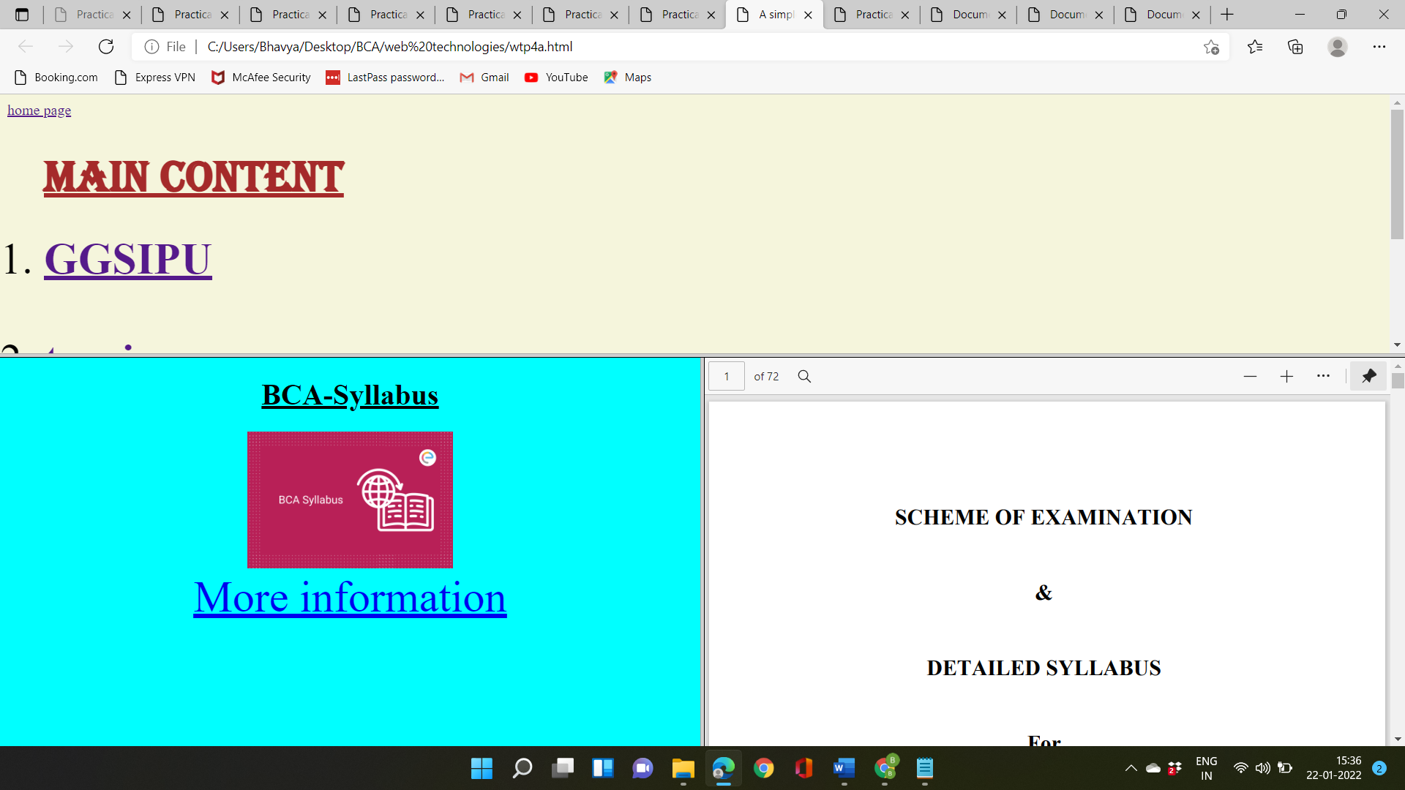

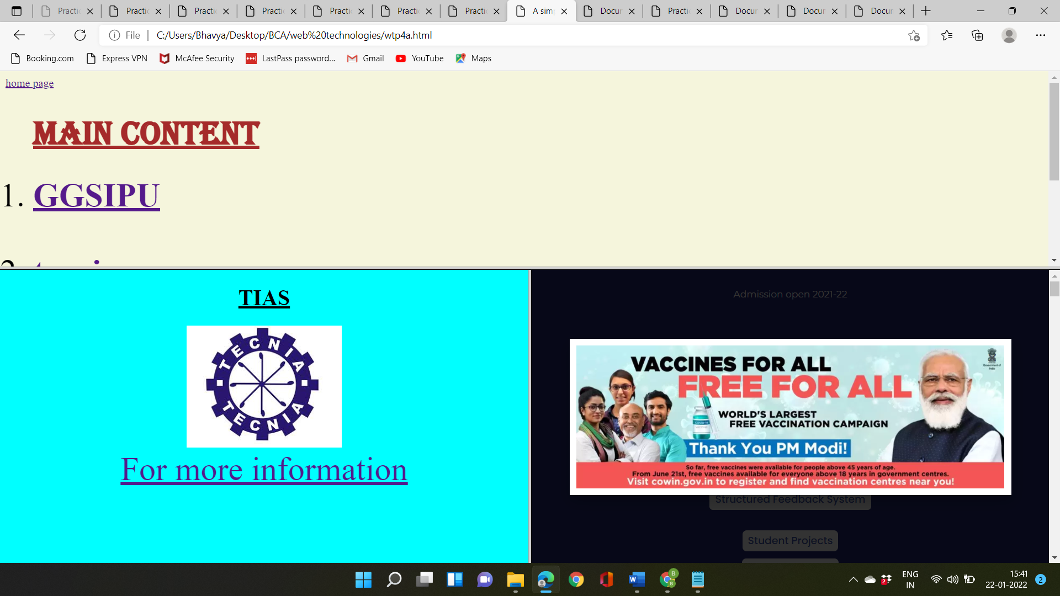

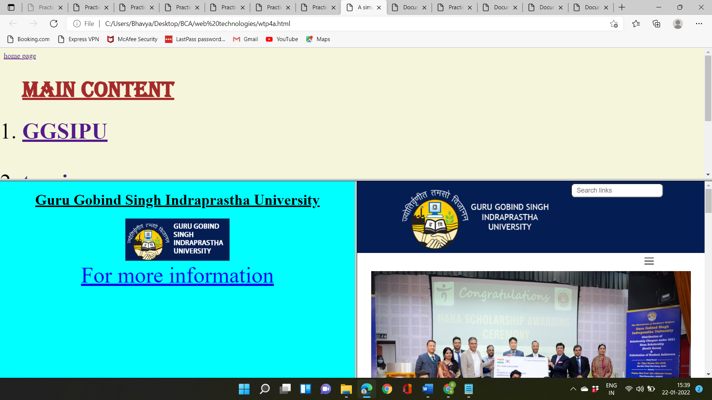

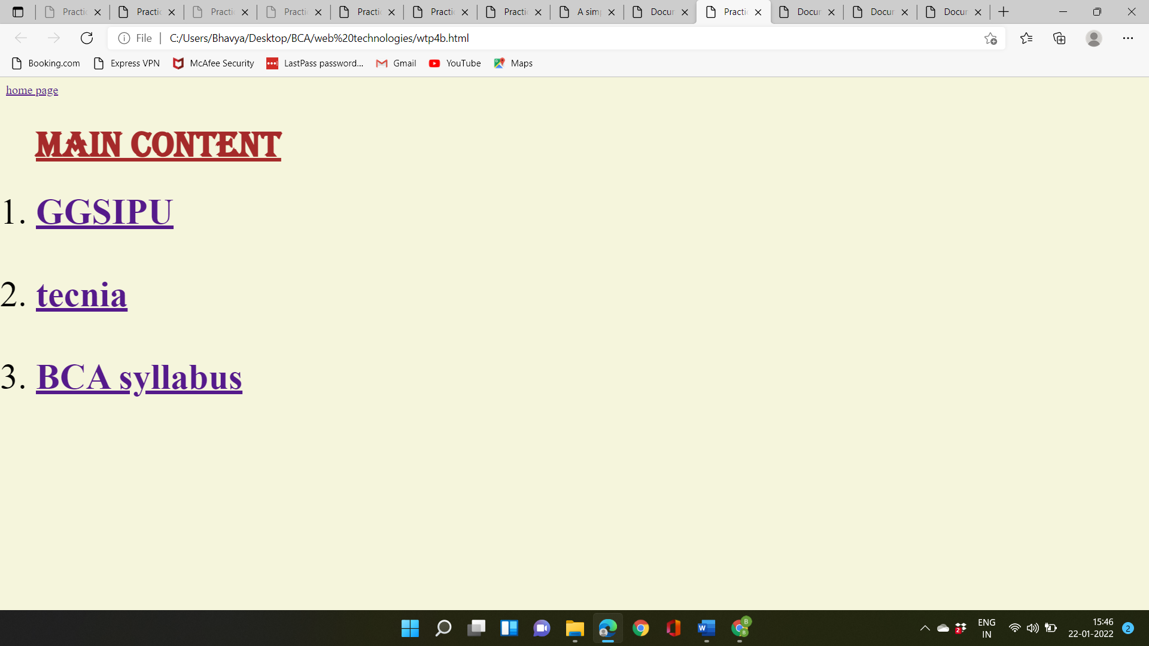



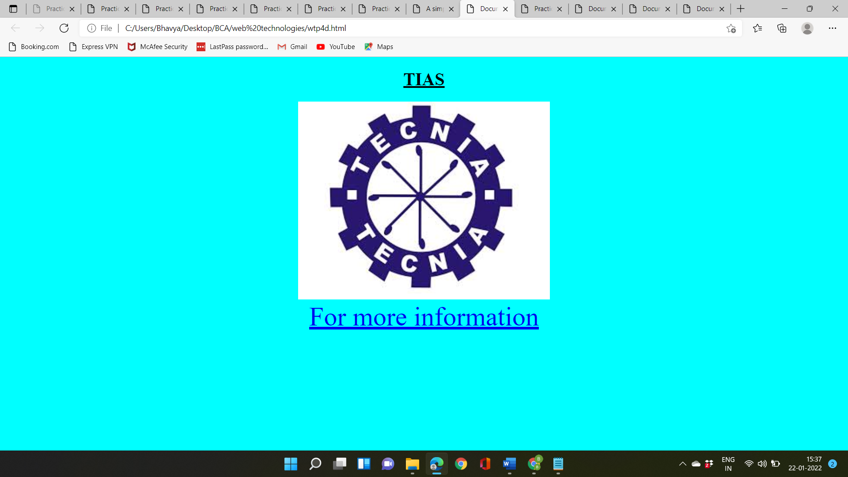

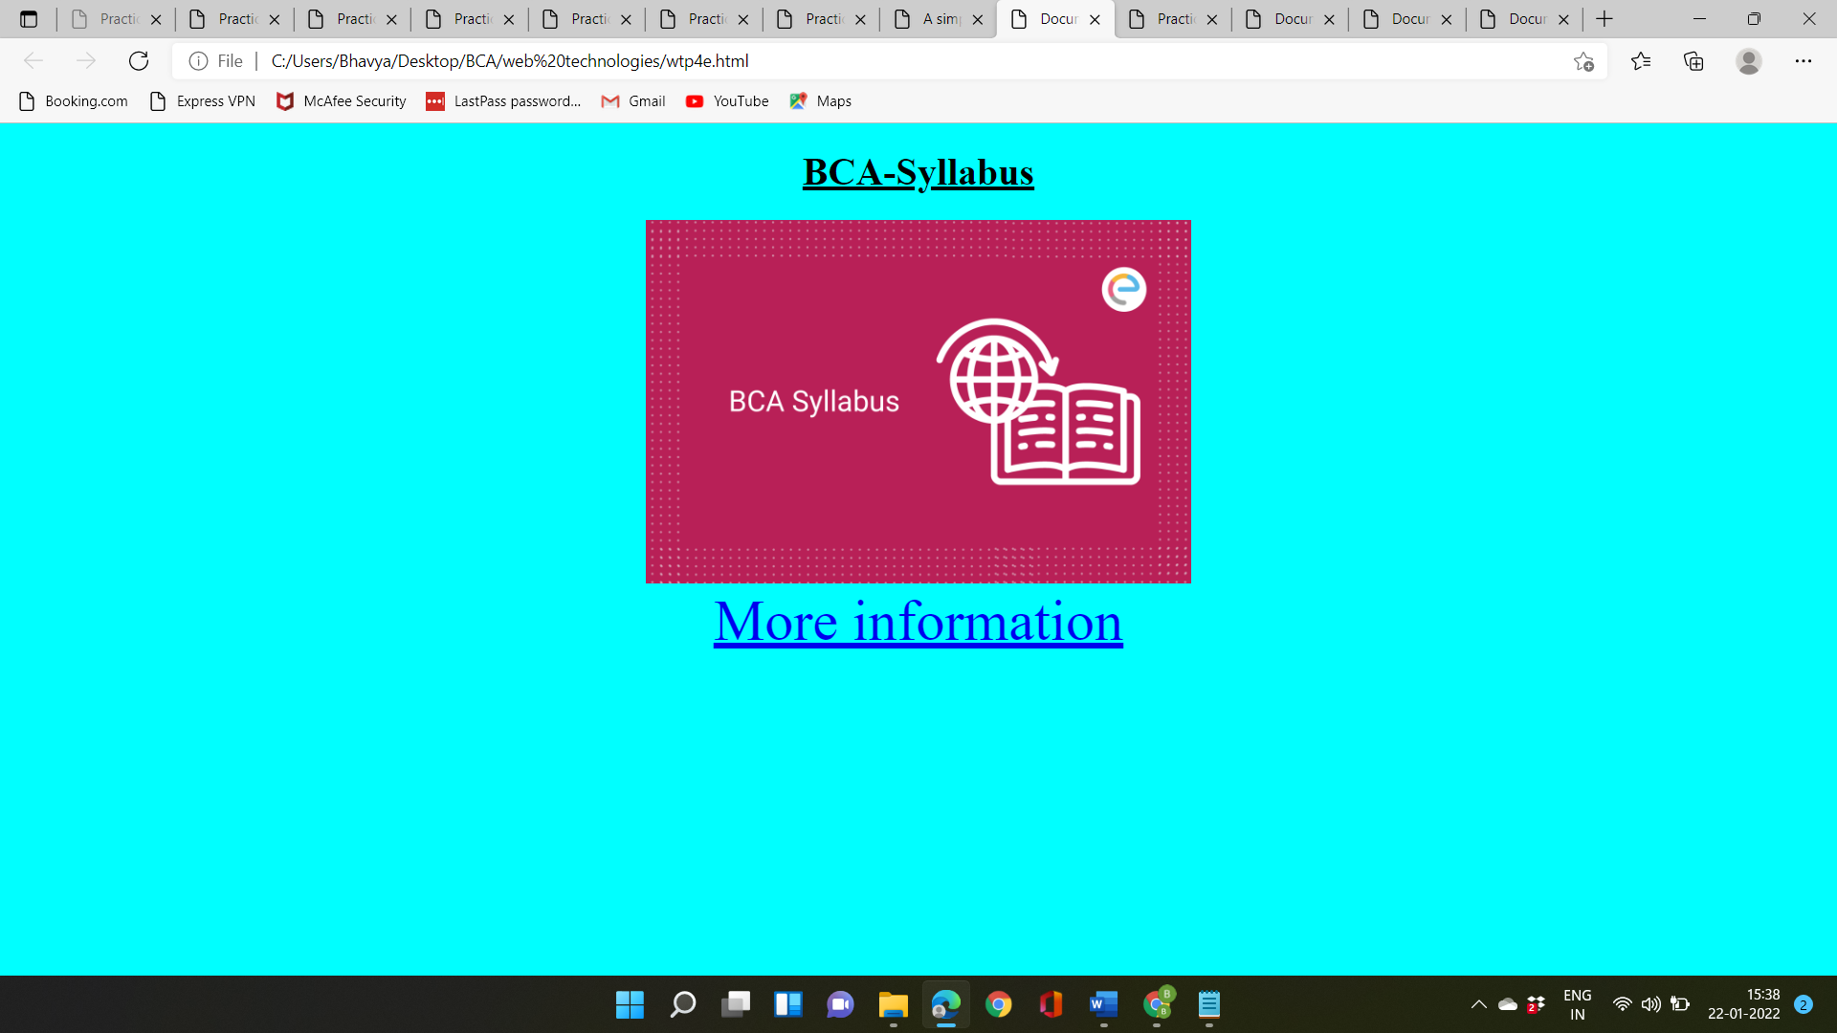

**Practicle-5**

**Objective:-** Make an image map showing the usage of shape, coords, href attributes in map definition Link each hotspot to their respective details. All the web pages should be designed with proper background color, images, font styles and heading.

Source code:-

<!DOCTYPE html>

<html lang="en">

<head>

<title>Document</title>

</head>

<body bgcolor="lightsalmon">

<a href="file:///C:/Users/Bhavya/Documents/wtp1a.html"><font color="gold" size="5"> Home page</font></a> <font face="Monotype Corsiva" color="brown" size="8">

<marquee direction="left" behavior-"alternate"><u>IMAGE MAPPING</u></marquee></font>

<hr size="6" color="black">

<center><img src="C:\Users\Bhavya\Downloads\webtech.png" width="20%" alt="workplace" usemap-"#workmap" border="10" style="border:3px solid yellow;"></center>

<map name-"workmap">

<area shape-"rect" coords="32,31,80,99" alt="BCA syllabus" href="file:///C:/Users/Bhavya/Desktop/BCA/web%20technologies/wtp5b.html">

<area shape-"rect" coords-"123, 30,194,94" alt="GGSIPU" href="file:///C:/Users/Bhavya/Desktop/BCA/web%20technologies/wtp5c.html">

<area shape="rect" coords="17,116,83,201" alt="tecnia" href="file:///C:/Users/Bhavya/Desktop/BCA/web%20technologies/wtp5d.html">

<area shape-"rect" coords="114,135,184,203" alt="BCA" href="file:///C:/Users/Bhavya/Desktop/BCA/web%20technologies/wtp5e.html">

</map>

<font color="black" size="5">

<center><p><b>Hints:</b><i>click on the image to open description of different sites</i></p></center>

</html>

</body>

</html>

. .

<!DOCTYPE html>

<html lang="en">

<head>

<title>Document</title>

</head>

<body bgcolor="papayawhip">

<a href="file:///C:/Users/Bhavya/Desktop/BCA/web%20technologies/wtp5a.html"><font color="black">click here to go image map page</font></a>

<font face="algerian" color="black" size="20"><center><h1><b><u>BCA-syllabus</u></b></h1></font>

<img src="C:\Users\Bhavya\Downloads\BCA-Syllabus.png" width="400px" height="300px"> </center>

<center><a href=""><font color="brown" size="8" face="Algerian"> CLICK HERE FOR FULL BCA SYLLABUS</font></a></center>

</body>

</html>

. .

<!DOCTYPE html>

<html lang="en">

<head>

<title>Document</title>

</head>

<body bgcolor="pink">

<a href="file:///C:/Users/Bhavya/Desktop/BCA/web%20technologies/wtp5a.html"><font color="black" size="6">click here to go image map page</font></a>

<font size="20"face="algerian" color="brown"><center><h1><b><u>GGSIPU</u></b></h1></font>

<img src="C:\Users\Bhavya\Downloads\GGSIPU_LOGO.png"></center>

<center>

<a href="http://www.ipu.ac.in/"><font color="brown" size="20">CLICK HERE TO GO TO GGSIPU SITE</a> </font>

</center>

</body>

</html>

. .

<!DOCTYPE html>

<html lang="en">

<head>

<title>Document</title>

</head>

<body bgcolor="peachpuff">

<a href="file:///C:/Users/Bhavya/Desktop/BCA/web%20technologies/wtp5a.html"><font color="black">click here to go image map page</font></a>

<font size="20" face="algerian" color="brown"><center><H1><b><u>TECNIA</u></b></H1></font>

<img src="C:\Users\Bhavya\Downloads\Technia-logo.png">

</center>

<center>

<a href="https://tiaspg.tecnia.in/"><font color="brown" size="20">CLICK HERE TO GO TO TECNIA WEBSITE</a></font></center>

</body>

</html>

. .

<!DOCTYPE html>

<html lang="en">

<head>

<title>Document</title>

</head>

<body bgcolor="lightcyan">

<a href="file:///C:/Users/Bhavya/Desktop/BCA/web%20technologies/wtp5a.html"><font color="black" size="6">click here to go image map page</font></a>

<font size="20" face="algerian" color="coral"><center><H1><b><u>B.C.A</u></b></H1></center></font>

<center><img src="C:\Users\Bhavya\Downloads\bca.jpg"> </center>

<font color="brown" size="20">Bachelor in Computer Application (BCA) is an undergraduate degree course in computer applications. ... The duration of the course is 3 years and divided into 6 semesters. It comprises of the subjects like database, networking, data structure, core programming languages like 'C' and 'java'</font>

</body>

</html>

Output:-

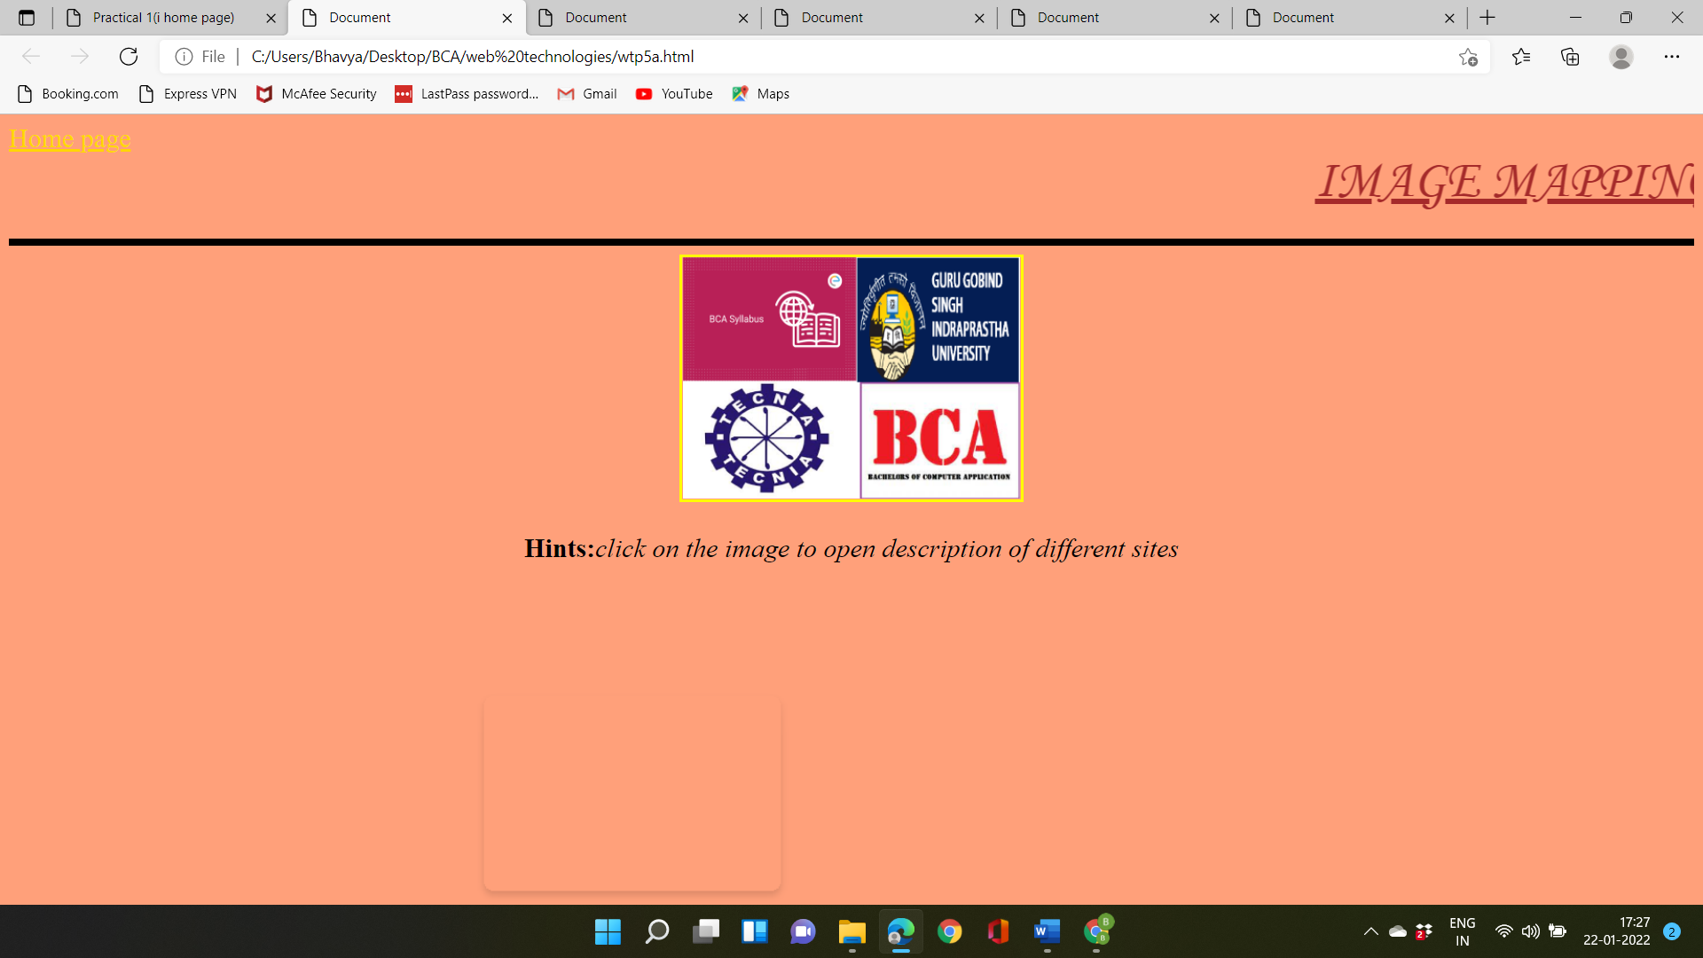

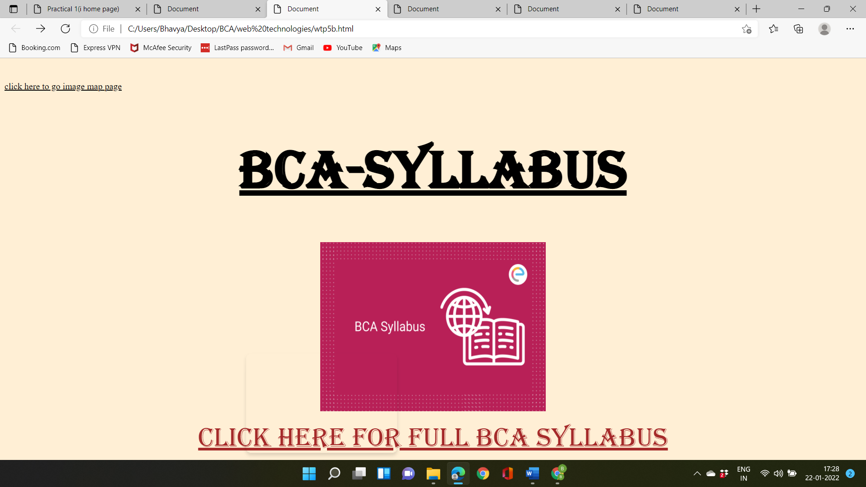

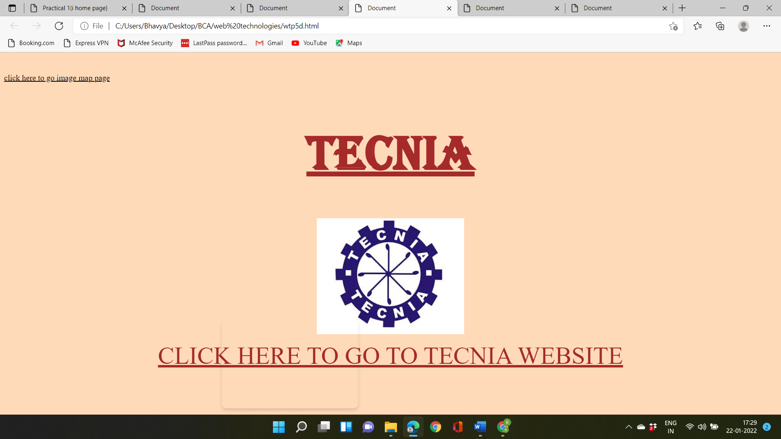

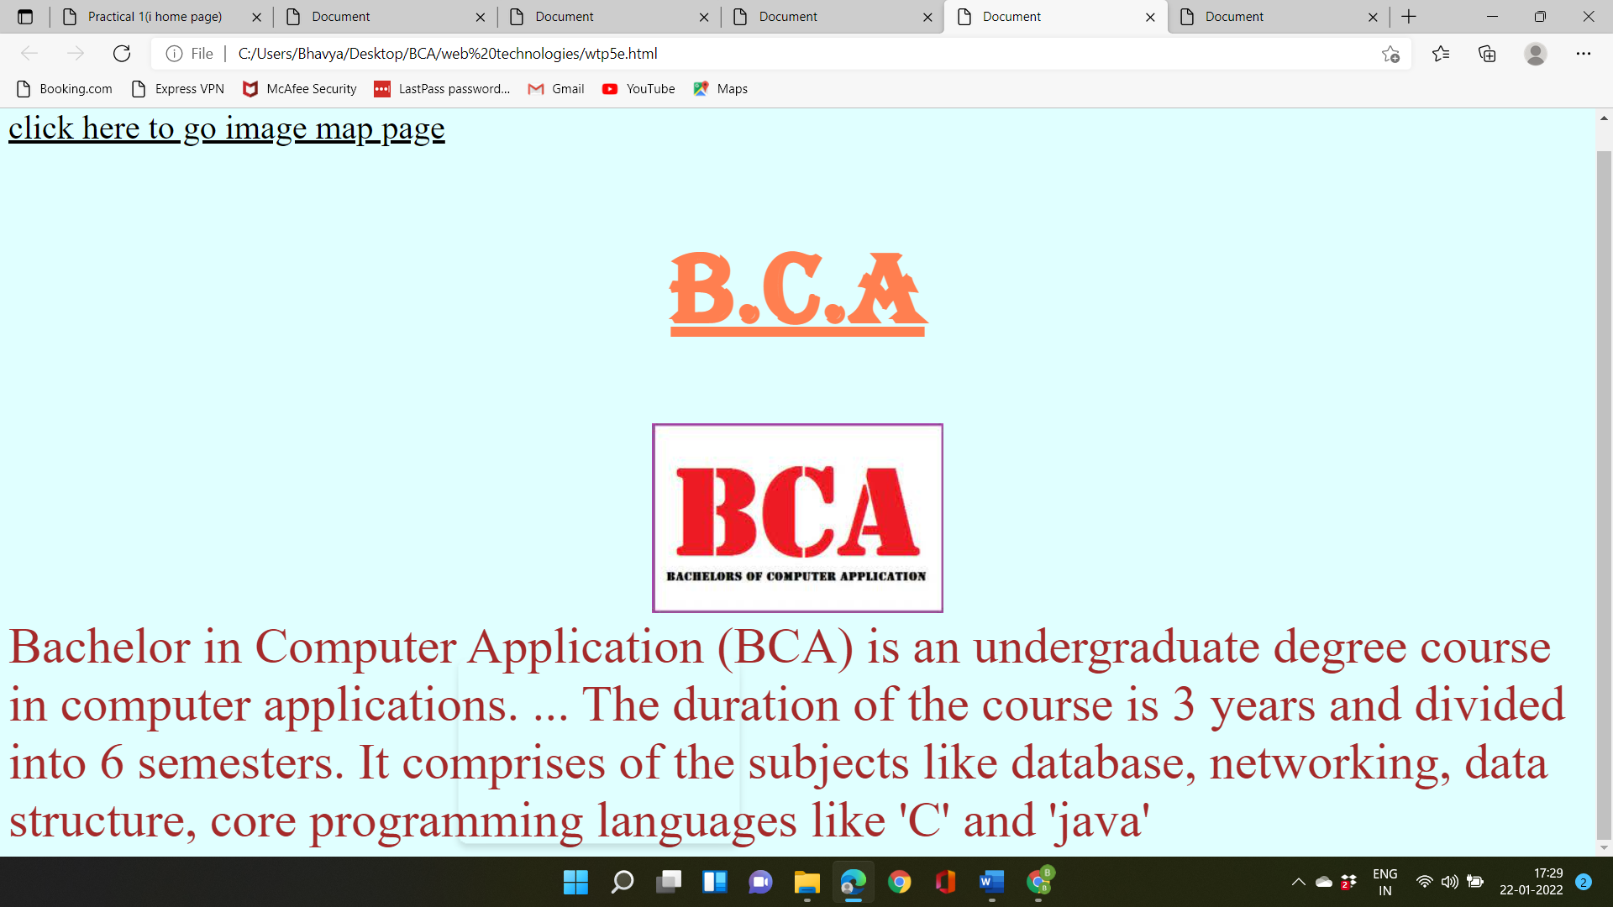

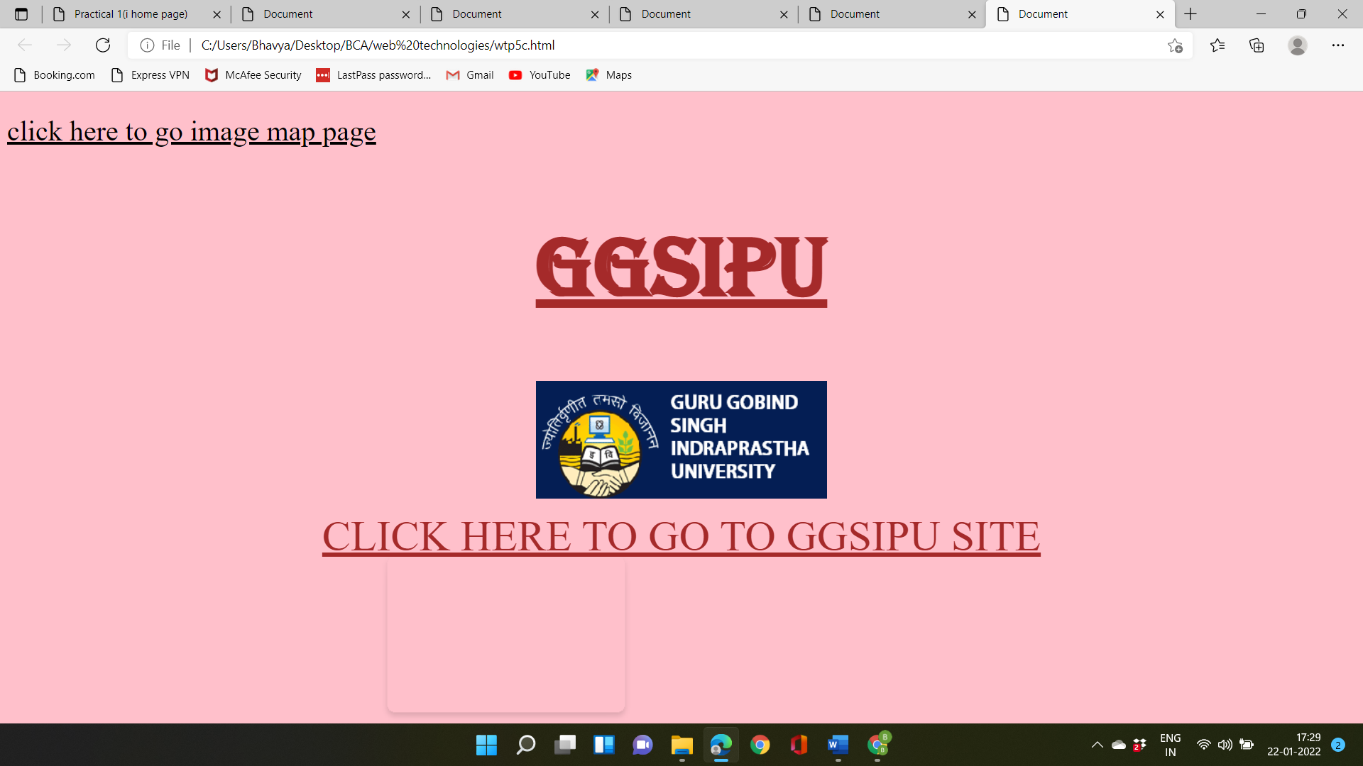

**Practical-6**

**Objective:-** Design student registration form for admission in college.

Source code:- <!DOCTYPE html>

<html lang="en">

<head>

<title>Document</title>

</head>

<body bgcolor="lavender">

<center><img src="C:\Users\Bhavya\Downloads\Tecnia-Institute-of-Advanced-Studies-LOGO.jpg" weidth="800px" height="100px"></center>

<p><a href="file:///C:/Users/Bhavya/Documents/wtp1a.html" align="left"><font size="6">click here to go Home page</a></p> <a href="https://tiaspg.tecnia.in/" align="right">click here to go to tecnia website</a> </font>

<pre><center><font face="algerian" ><h1><B><u>Student Registration Form</u></B></h1>

</center>

<pre>

NAME : <input type="textbox" size="15" maxlength="15"> DATE OF BIRTH (DOB): <input type="date"><BR>

FATHER'S NAME: <input type="textbox" size="15" maxlength="15"> MOTHER'S NAME: <input type="textbox" size="15" maxlength="15"> <br>

FATHER'S MOBILE NO.: <input type="number" size="10" MAXLENGTH="10"> MOTHER'S MOBILE NO.: <input type="number" size="10" MAXLENGTH="10"><BR>

ADDRESS: <textarea></textarea> <BR>

STATE: <SELect>

<option name="x"> UP</option>

<option name="x"> MP</option>

<option name="x"> DELHI</option>

<option name="x"> SIKKIM</option>

<option name="x"> J&K</option>

<option name="x"> ASSAM</option>

<option name="x"> HARYANA</option>

<option name="x"> BIHAR</option>

<option name="x"> MAHARASTRA</option>

</SELect><BR>

GENDER : <input type="radio" name="x">MALE

<input type="radio" name="x">FEMALE

<input type="radio" name="x">OTHERS<BR>

PASSED 12TH STANDARD OR EQUIVALENT: <input type="radio" name="x"> YES <input type="radio" name="x"> NO<BR>

SUBJECTS: <input type="checkbox"> English

<input type="checkbox"> Hindi

<input type="checkbox"> Maths

<input type="checkbox"> Biology

<input type="checkbox"> chemistry

<input type="checkbox"> Physics

<input type="checkbox"> Economics

<input type="checkbox"> Accountancy

<input type="checkbox"> Business STUDIES

<input type="checkbox"> Physical Education

<input type="checkbox"> Information Practices

<input type="checkbox"> Computer Science

<input type="checkbox"> Fine Arts<BR>

<input type="button" value="Submit">

</pre>

</body>

</html>

Output:-

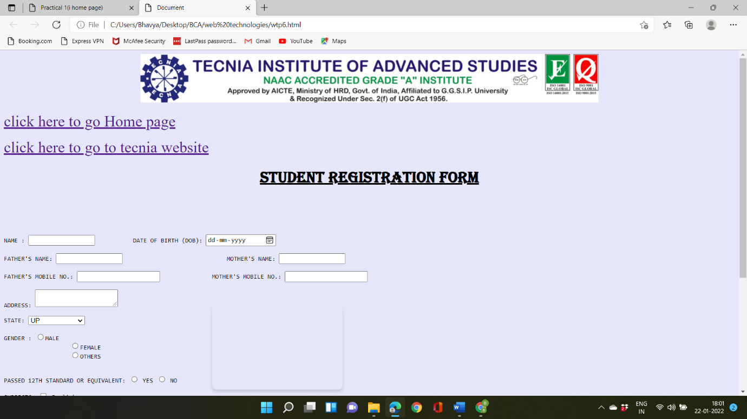

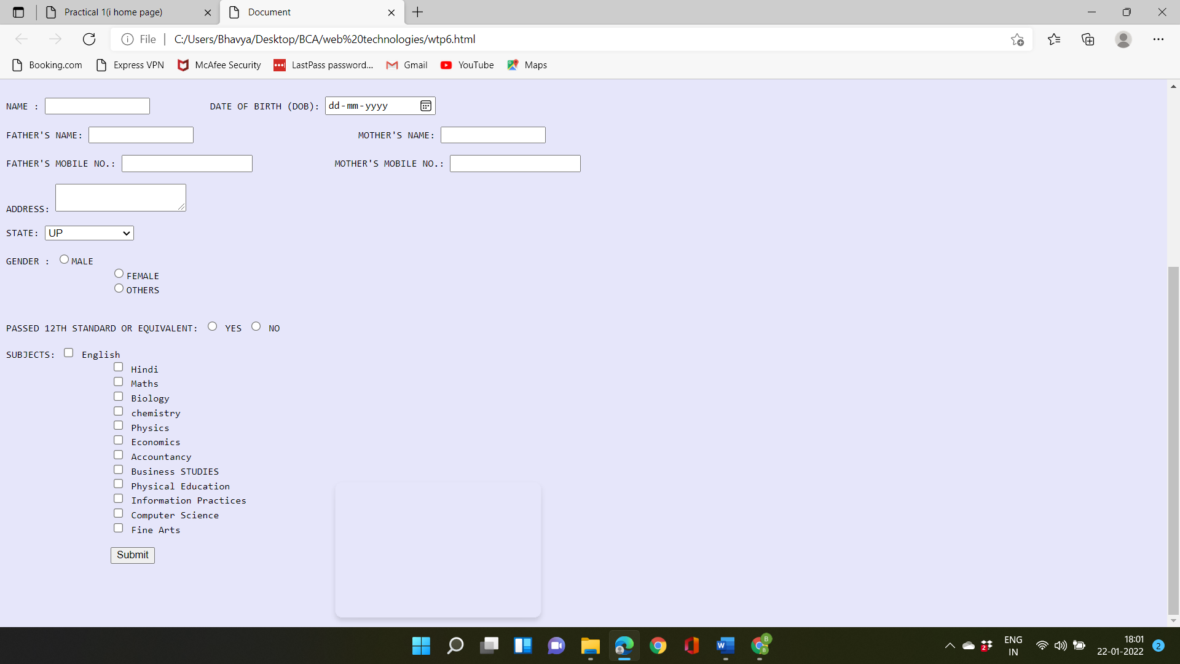

**Practicle-7**

**Objective:- Create a webpage and show the usage of inline and internal style sheet and external style sheet?**

**Source:-**

<html>

<head>

<link rel="stylesheet" href="mystyles.css">

</head>

<body><font color="gold" size="4">

Inline styles relate to a specific HTML tag, using a style attribute with a C55 rule to style a particular page element. They're useful for quick and permanent changes but are less flexible than external and internal stylesheets, as each inline style you create must be edited separately if you're making a design change.

<br>

<br>

An internal stylesheet holds CSS rules for the page in the head section of the HTML file. The rules only apply to that page, but you can configure css classes and IDS to style multiple elements in the page code. Again, a single change to the css rule will apply to all tagged page elements.

<br>

<br>

An external stylesheet is a standalone .css file linked from a web page. using external stylesheets, you can apply rules to multiple web pages. If you ever need to make widespread changes to your website design, a single change in the stylesheet can be applied to all linked pages, saving lots of time and effort.

</body></font>

<hr color="lavender">

<style>

body{background-color:royalblue; }

h1 {color:lightsalmon; margin-left:40px;}

</style>

</body>

<body>

<h1><font face="Algerian"><center><u>This is an internal css.</h1></font></center></u>

</body>

<body>

<p style="color: pink; text-align: center">

<font size="5"><b>This is an inline css. styles have been defined for this CSS in a single element.</font></b>

</P>

</body>

</html>

**Output:-**

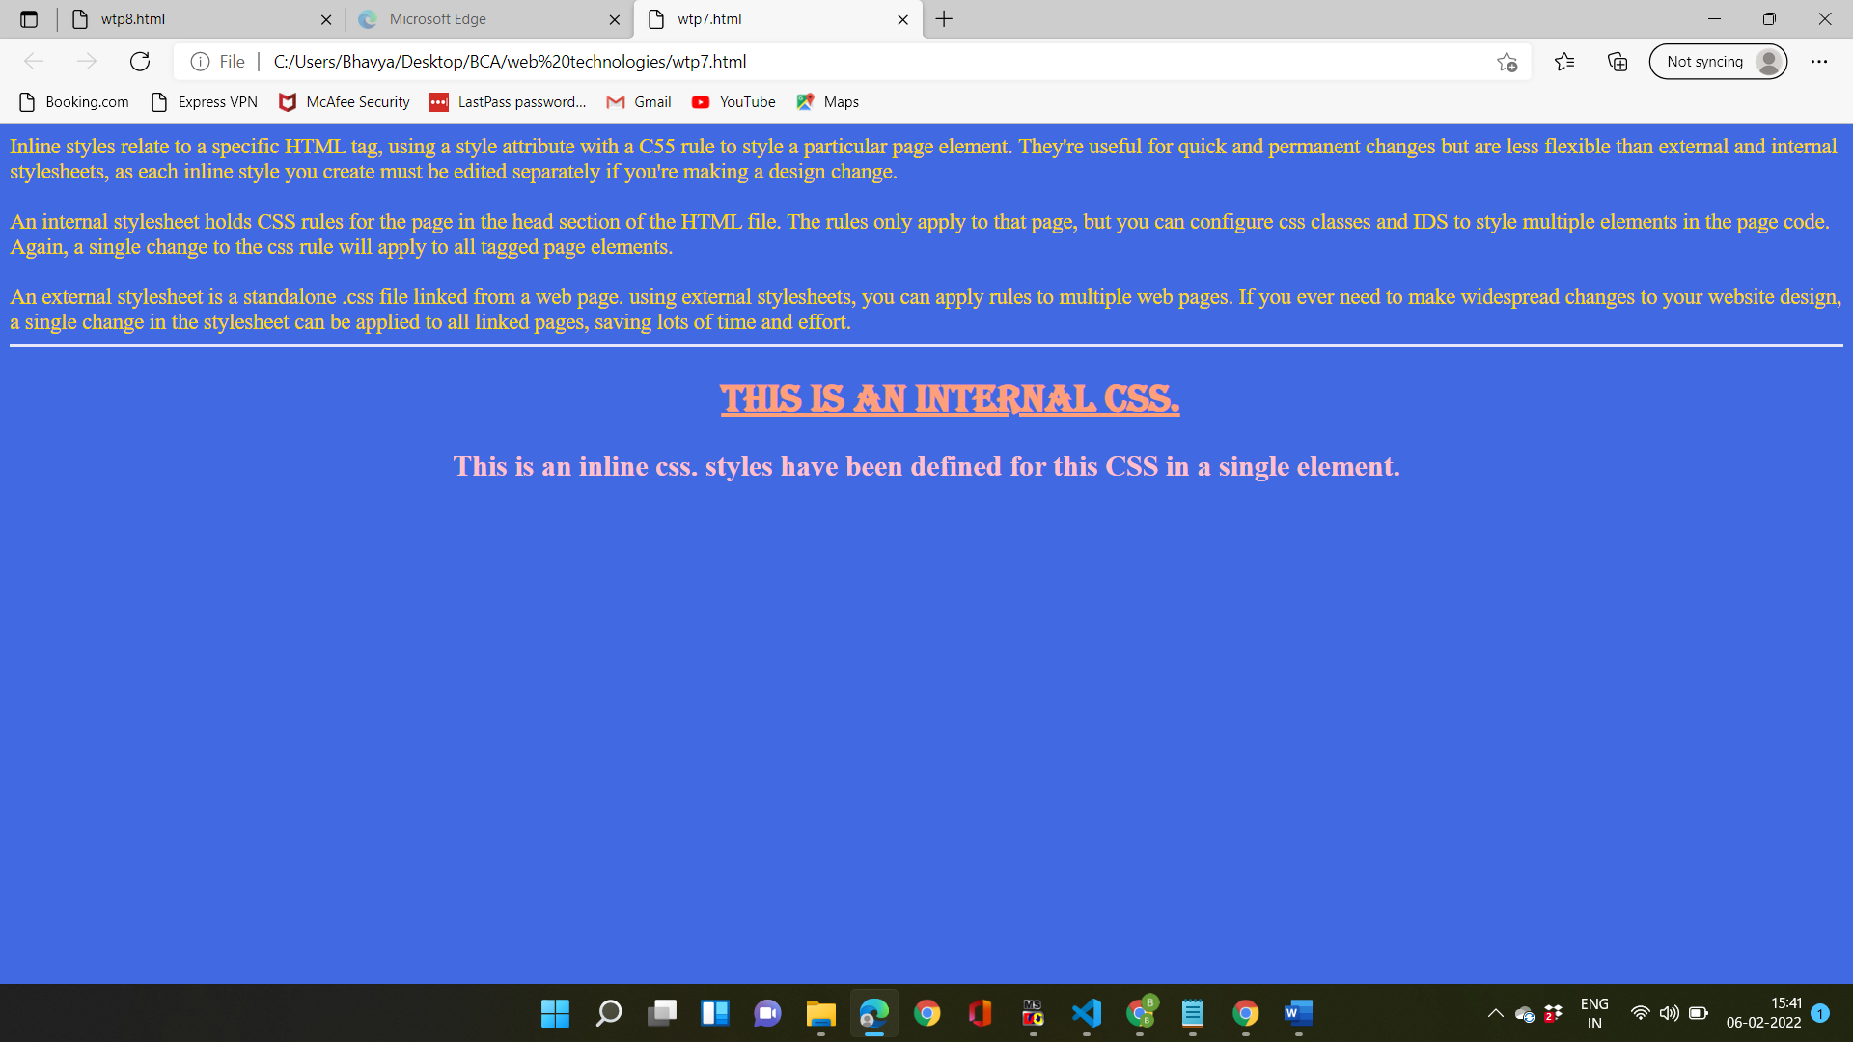

**Practicle-8**

**Objective:-** **create a web page containing a background image and apply all the background styling attributes.**

**Source code:-**

<html>

<head>

<style>

body{

background - image : url("/GGSIPU_LOGO.png") ;

background - repeat : y ;

background - position : right top ;

margin - right ; 200px ; background - attachment : scroll ;

}

</style>

</head>

<body>

</body>

</html>

Output:-



**Practicle-9**

**Objective:- Create a webpage showing the usage of font styling attributes.**

**Source code:-** <!DOCTYPE html>

<html>

<head>

<link rel="stylesheet" href="https://fonts.googleapis.com/css?family=Sofia&effect=neon|outline|emboss|shadow-multiple">

<style>

p.normal {font-weight: normal}

p.oblique{font-style: oblique; font-weight: lighter;}

p.italic{font-style: italic; font-weight: bold;}

p.thicker {font-weight: 9000;}

p.small{font-variant: small-caps;}

body {

font-family: "Sofia", sans-serif;

font-size: 10px;

}

</style>

</head>

<body>

<h1 class="font-effect-neon">Neon Effect</h1>

<p class="small">this is paragraph</p>

<h3 class="font-effect-emboss">Effect</h3>

<p class="thicker">this is paragraph</p>

<p class="italic">this is paragraph</p>

<h2 class="font-effect-outline">Outline Effect</h2>

<p class="oblique">this is paragraph</p>

<p class="normal">this is paragraph</p>

<h4 class="font-effect-shadow-multiple"> Shadow Effect</h4>

</body>

</html>

**Output:-**

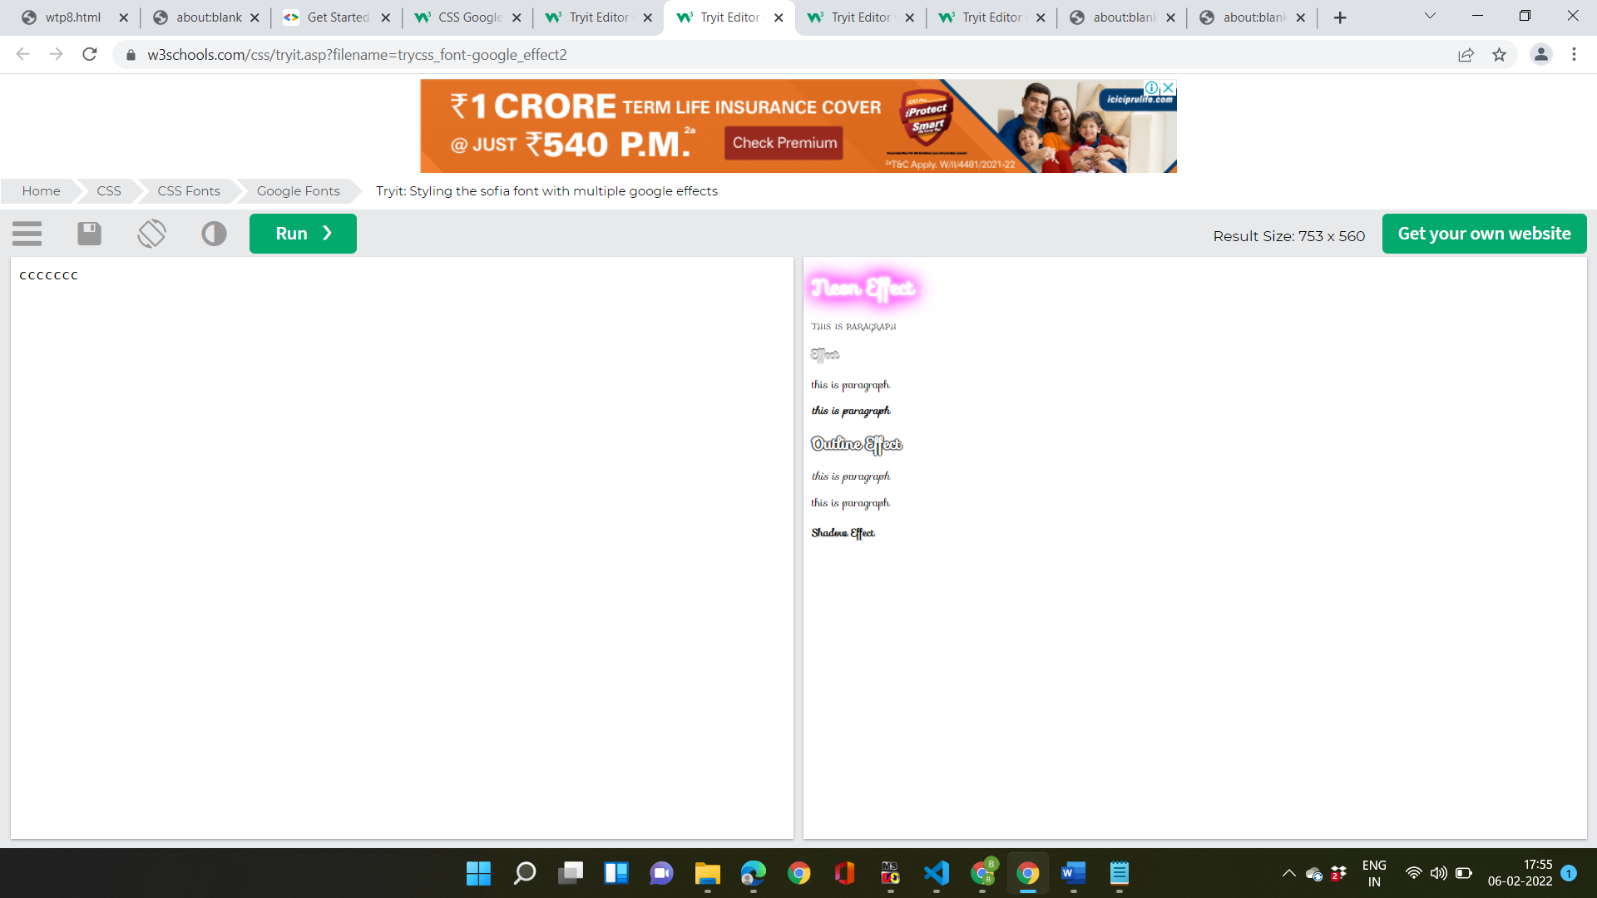

**Practicle-10**

**Objective:- create a webpage and apply all text styling attributes use Id and class selector.**

**Source code:-**

<!DOCTYPE html>

<html>

<head>

<style>

#myHeader {

background-color: lightblue;

color: black;

padding: 10px;

text-align: center;

}

.sub {

background-color: hotpink;

color: purple;

padding: 5px;

}

</style>

</head>

<body>

<h1 id="myHeader">BCA-SUBJECTS</h1>

<h2 class="sub">Web-technologies</h2>

<p>WEB-TECH-LAB</p>

<h2 class="sub">C-LANGUAGE</h2>

<p>C-LABS</p>

<h2 class="sub">FCIT</h2>

<p>IT-LAB</p>

</body>

</html>

**Output:-**

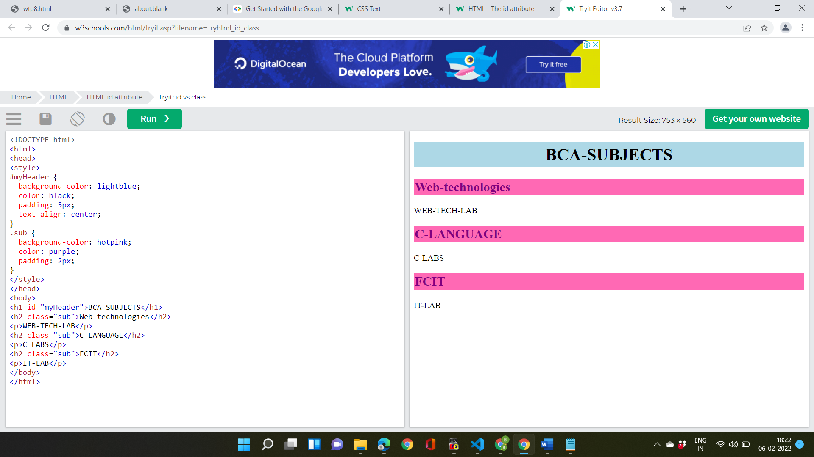

**Practicle-11**

**Objective:- create a webpage and implement all list styling attributes.**

**Source code:-**

<html>

<head>

<style>

h1{text-align: center; color:brown; }

p{color: red;}

ul.a{list-style-type: square; background: #cce5ff; border-left: 5px solid blue; }

ul.b{list-style-type:círcle; background: #ff2304;}

ul.c{list-style-type: bullet; background: #ff99ff; }

ul.d{list-style-type: armenian; background: #283268;}

ol.w{list-style-type: decimal-leadin-zero; background: #45ff11; }

ol.x{list-style-type: upper-roman; background: #8899ff; border-left: 6px solid blue; }

ol.x{list-style-type: lower-alpha; background: #45ff56;}

ol.x[list-style-type: disc; background: #959900;}

</style>

</head>

<body>

<h1>GENRES</h1> <p>Autobiographies</p>

<ul class="a"> <li>An autobiography</li>

<li>The test of my life</li>

<li>Playing it my way</li>

</ul>

<p>Mythologies</p>

<ul class="b">

<li>The shiva triology</li>

<li>Metamorphos</li>

</ul>

<p>Horror:</p>

<ul class="c">

<li>The woman in black</li>

<li>Beloved</li>

</ul>

<p>Comics</p>

<ul class="d">

<li>Three men in a boat</li>

<li>The rudest book ever</li>

</ul>

<p>Biographies</p>

<ol cláss-"z">

<li>Akbarnama</li>

<li>The diary of a young girl</li>

</ol>

<p>Drama</p>

<ol class="w">

<li>Merchant </li>

<li>Julius Caesar </li>

</ol>

</body>

</html>

**Output:-**

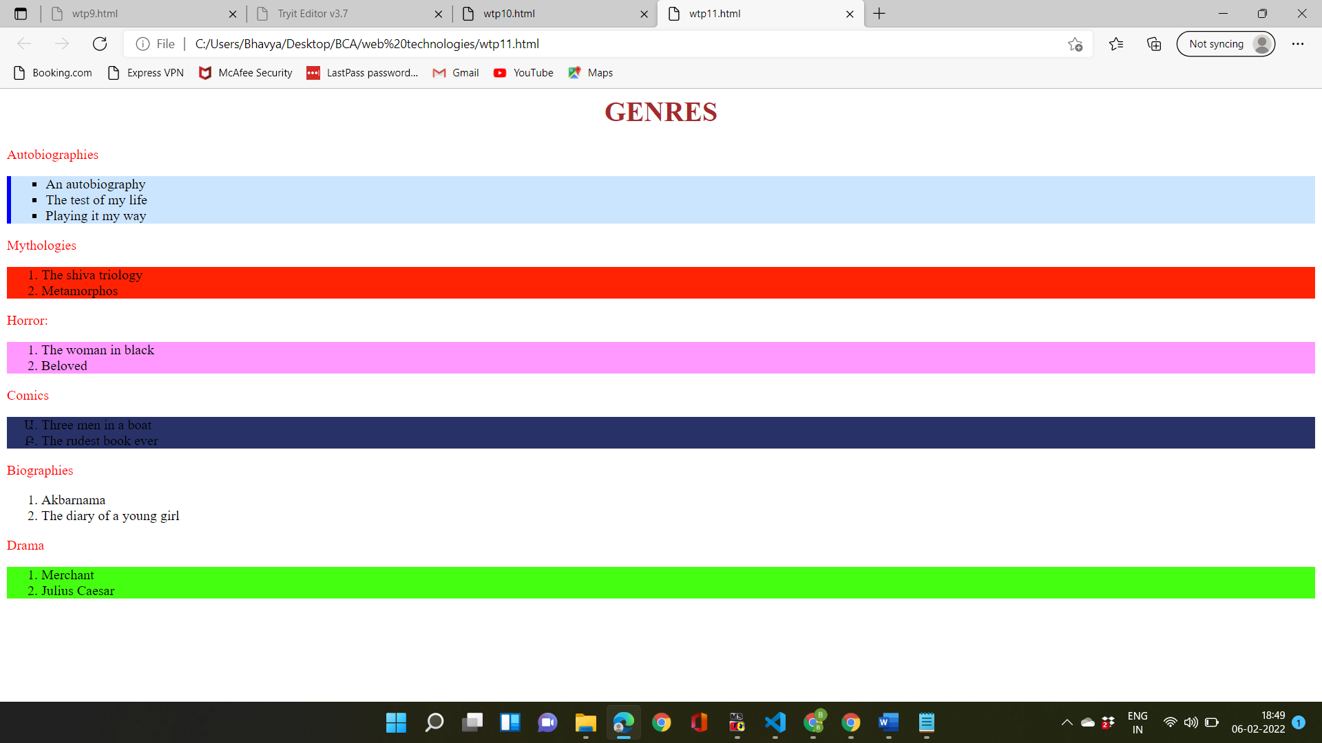

**Practicle-12**

**Objective:- create a webpage with three equal columbs.**

**Source code:-**

<html>

<head>

<style> body{background-color: lawngreen; }

.newspaper {column-count: 3; column gap: 40px; column-rule: 1px solid green;}

h2{column-span: all; }

</style>

</head>

<body> <div class="newspaper">

<h2>HTML,CSS,JAVA-SCRIPT</h2>

HTML-The HyperText Markup Language, or HTML is the standard markup language for documents designed to be displayed in a web browser. It can be assisted by technologies such as Cascading Style Sheets and scripting languages such as JavaScript.

CSS-Cascading Style Sheets is a style sheet language used for describing the presentation of a document written in a markup language such as HTML. CSS is a cornerstone technology of the World Wide Web, alongside HTML and JavaScript.

JAVASCRIPT-JavaScript, often abbreviated JS, is a programming language that is one of the core technologies of the World Wide Web, alongside HTML and CSS. Over 97% of websites use JavaScript on the client side for web page behavior, often incorporating third-party libraries.

</div>

</body>

</html>

**Output:-**

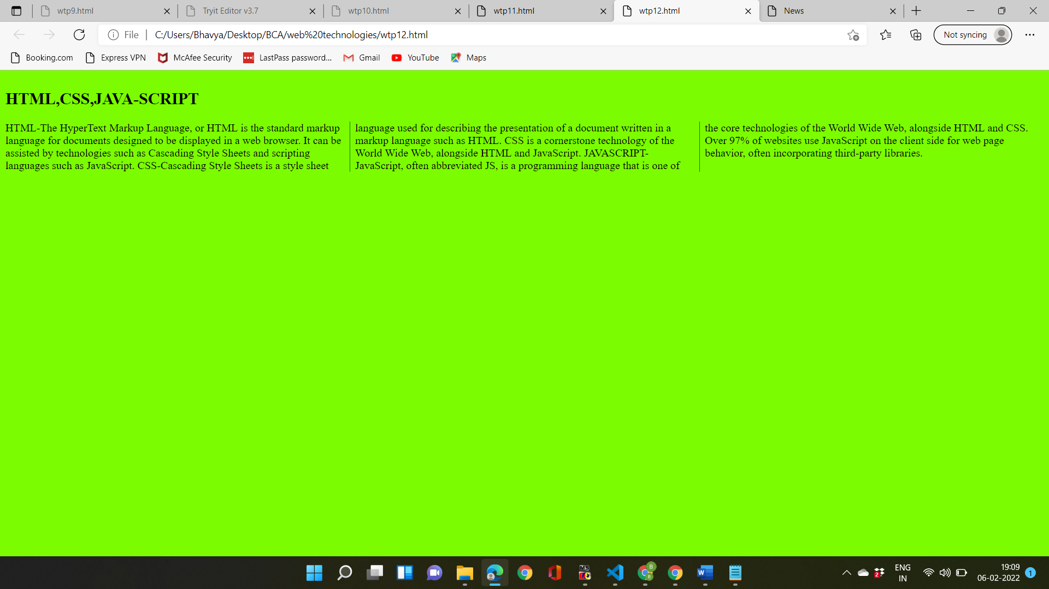

**Practicle-12**

**Objective:- create a webpage with three equal columb .using bootstrap.**

**Sorce code:-**

<!DOCTYPE html>

<html lang="en">

<head>

<title>web-tech</title>

<meta charset="utf-8">

<meta name="viewport" content="width=device-width, initial-scale=1">

<link href="https://cdn.jsdelivr.net/npm/bootstrap@5.1.3/dist/css/bootstrap.min.css" rel="stylesheet">

<script src="https://cdn.jsdelivr.net/npm/bootstrap@5.1.3/dist/js/bootstrap.bundle.min.js"></script>

</head>

<body>

<div class="container-fluid mt-3">

<h1>HTML,CSS,JAVASCRIPT</h1>

<p>WEB TECHNOLOGIES</p>

<div class="row">

<div class="col-sm-5 p-5 text-white-50 bg-primary">HTMLThe HyperText Markup Language, or HTML is the standard markup language for documents designed to be displayed in a web browser. It can be assisted by technologies such as Cascading Style Sheets and scripting languages such as JavaScript.</p></div>

<div class="col-sm-4 p-4 bg-danger text-white">CSS- Cascading Style Sheets is a style sheet language used for describing the presentation of a document written in a markup language such as HTML. CSS is a cornerstone technology of the World Wide Web, alongside HTML and JavaScript.</div>

<div class="col-sm-3 p-3 bg-success text-white">JavaScript- JavaScript, often abbreviated JS, is a programming language that is one of the core technologies of the World Wide Web, alongside HTML and CSS. Over 97% of websites use JavaScript on the client side for web page behavior, often incorporating third-party libraries</div>

</div>

</div>

</body>

</html>

**Output:-**

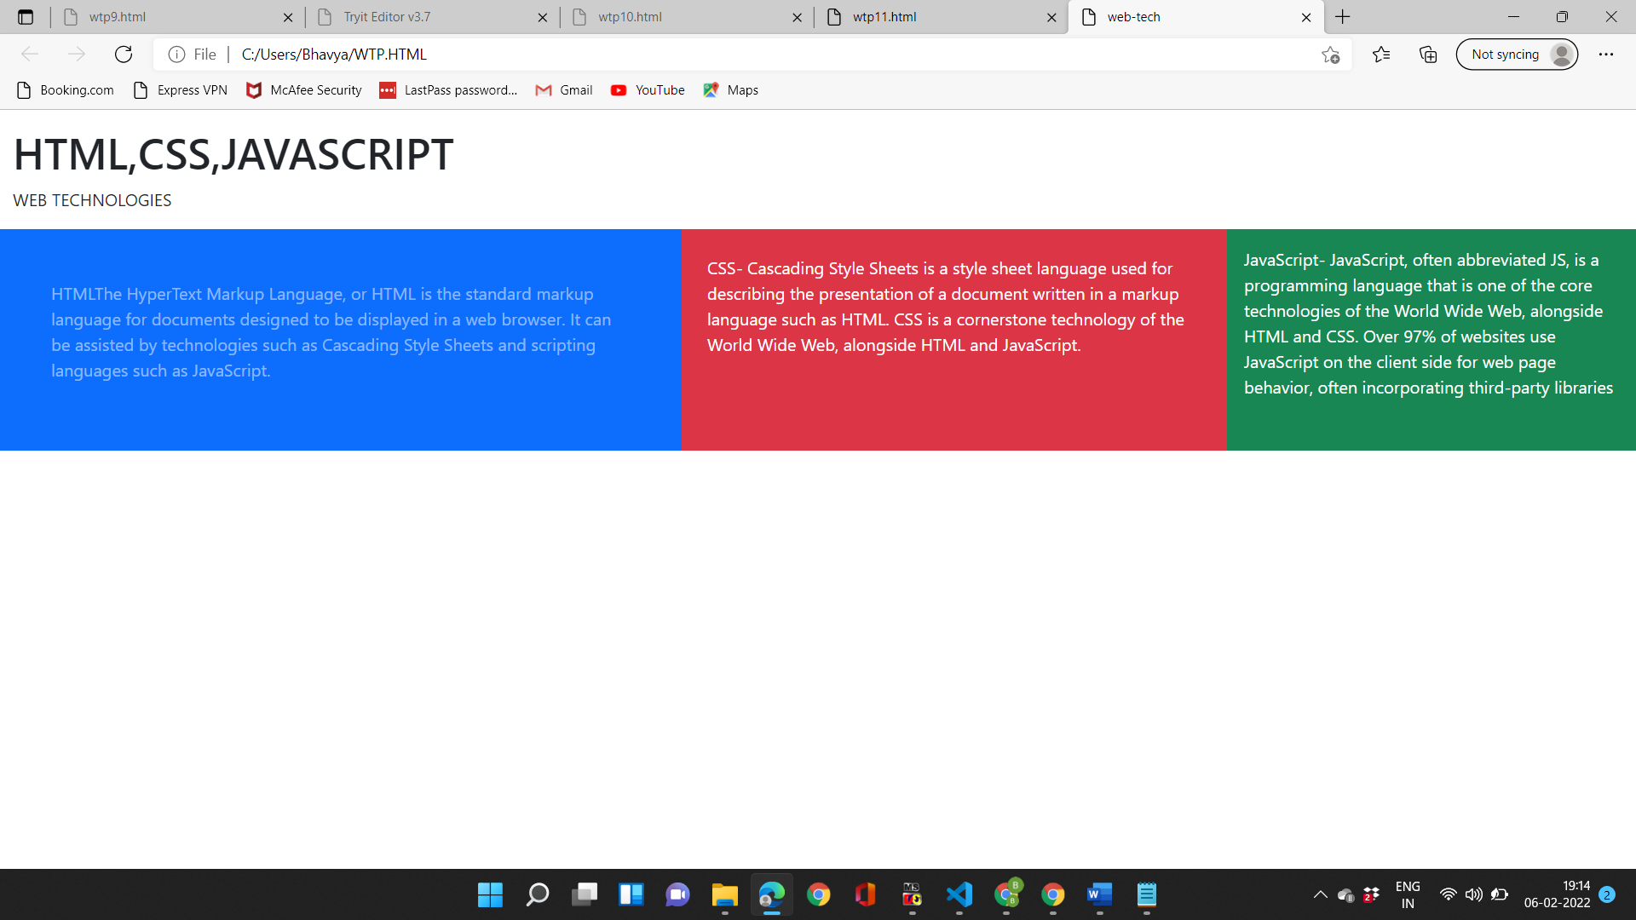

**Practicle-13**

**Objective:- create a webpage containing bootstrap table.**

**Source code:-**

<!DOCTYPE html>

<html lang="en">

<head>

<title>13</title>

<meta charset="utf-8">

<meta name="viewport" content="width=device-width, initial-scale=1">

<link rel="stylesheet" href="https://maxcdn.bootstrapcdn.com/bootstrap/3.4.1/css/bootstrap.min.css">

<script src="https://ajax.googleapis.com/ajax/libs/jquery/3.5.1/jquery.min.js"></script>

<script src="https://maxcdn.bootstrapcdn.com/bootstrap/3.4.1/js/bootstrap.min.js"></script>

</head>

<body>

<div class="container">

<table class="table">

<thead>

<tr>

<th>Firstname</th>

<th>shift</th>

<th>program</th>

<th>Email</th>

</tr>

</thead>

<tbody>

<tr>

<td>Bhawya Garg</td>

<td>morning</td>

<td>BCA</td>

<td>bhawyag5@gmail.com</td>

</tr>

<tr class="success">

<td>muskan</td>

<td>morning</td>

<td>BCA</td>

<td>muskan@gmail.com</td>

</tr>

<tr class="danger">

<td>himesh</td>

<td>mornig</td>

<td>BCA</td>

<td>himesh@gmail.com</td>

</tr>

<tr class="info">

<td>khyati</td>

<td>morning</td>

<td>BCA</td>

<td>khyati@gmail.com</td>

</tr>

<tr class="warning">

<td>ankush</td>

<td>morning</td>

<td>BCA</td>

<td>ankush@gmail.com</td>

</tr>

</tbody>

</table>

</div>

</body>

</html>

**Output:-**

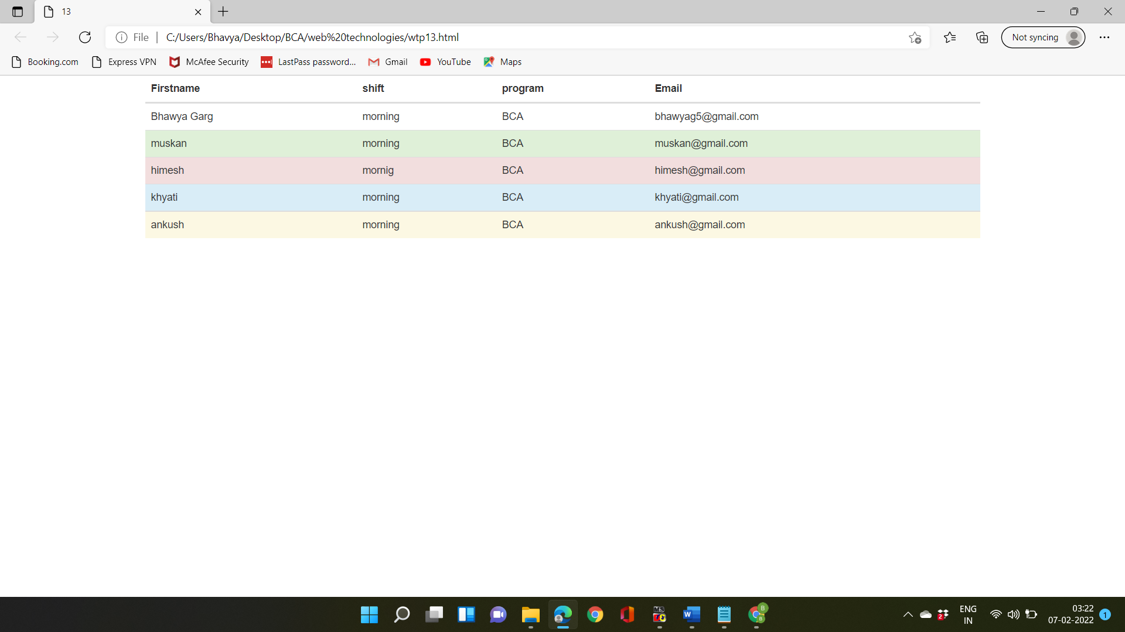

**Practicle-14**

**Objective:- create a webpage containing various types of images.**

**Source code:-**

<!DOCTYPE html>

<html lang="en">

<head>

<title>Bootstrap Example</title>

<meta charset="utf-8">

<meta name="viewport" content="width=device-width, initial-scale=1">

<link rel="stylesheet" href="https://maxcdn.bootstrapcdn.com/bootstrap/3.4.1/css/bootstrap.min.css">

<script src="https://ajax.googleapis.com/ajax/libs/jquery/3.5.1/jquery.min.js"></script>

<script src="https://maxcdn.bootstrapcdn.com/bootstrap/3.4.1/js/bootstrap.min.js"></script>

</head>

<body bgcolor="lightpink">

<div class="container mt-3">

<h2 style="font-weight: bolder; color: #355C7D;">rounded corners</h2>

<p style="font-weight: bolder; color: #355C7D;">the rounded class adds rounded corners to an image</p>

<img src="C:\Users\Bhavya\Pictures\Saved Pictures\laptop-backgrounds-nature-images-1920x1200-wallpaper-preview.jpg" class="img-rounded " alt="Cinque Terre" width="304" height="236">

<h2 style="font-weight; bolder; color: #355C7D;">circle</h2> <p style="font-weight: bolder; color:#355C7D;"> rounded circle class adds corners to an image: </p>

<img src="C:\Users\Bhavya\Pictures\Saved Pictures\3d-waterfall-nature-wallpaper-500x500.jpg" class="img-circle" alt="Cinque Terre" width="304" height="236">

<h2 class="float style="font-weight: bolder; color: #355C7D;" align="right">float align </h2>

<p class="float" style="font-weight: bolder; color: #355C7D;" align="right">image align on right using float end</p>

<img src="C:\Users\Bhavya\Pictures\Saved Pictures\road-1072821__340.jpg" class="img-float-end" alt="Cinque Terre" width="304" height="236" align="right">

</div>

</body>

</html>

**Output:-**

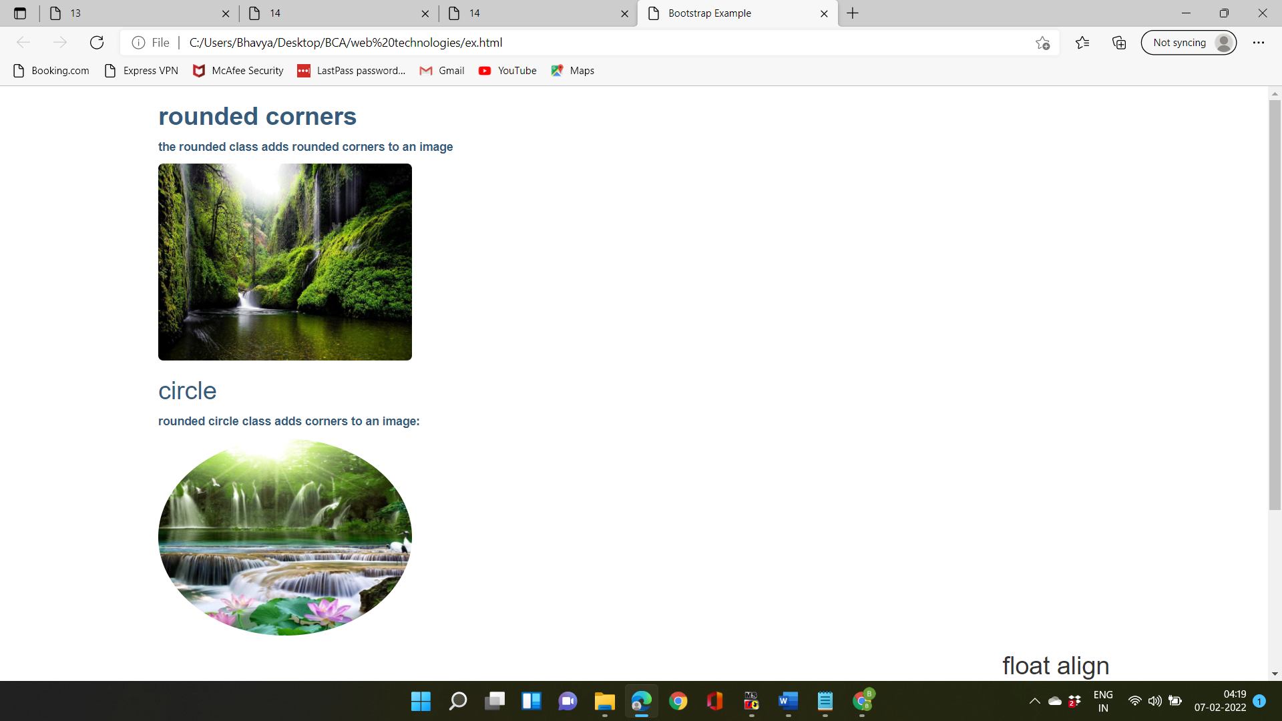

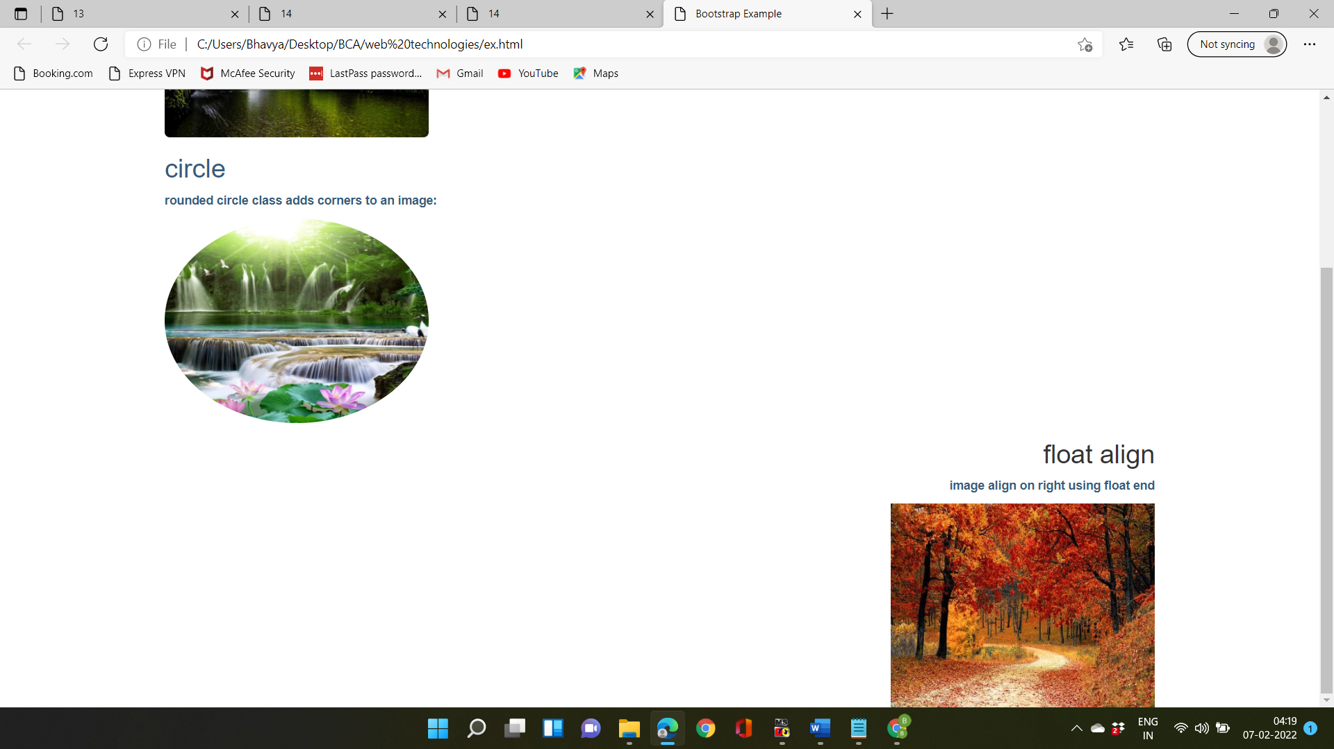

**Practicle-15**

**Source code:-**

<html>

<head>

<title>15</title>

<meta charset="utf-8">

<meta name="viewport" content="width-device-width, initial-scale=1">

<link href="https://cdn.jsdelivr.net/npm/bootstrap@5.1.3/dist/css/bootstrap.min.css" rel="stylesheet" integrity="sha384

18mE4kWBq781YhF1dvkuhfTAU6auU8tT94WrHftjobrCEXSU10Boqy12QvZ6jIW3" crossorigin="anonymous">

<script src="https://cdn.jsdelivr.net/npm/bootstrap@5.1.3/dist/js/bootstrap.bundle.min.js"></script>

<style>

a:hover + di{display: block;

color:#73C6B6;

font size: 20px;}

body{ background: url("C:\Users\pikapii \Desktop\Camera Roll\50 Minimalist Desktop Wallpapers and Backgrounds (2021 Edition).png");

background-size:2550px;}

</style>

</head>

<body>

<div class="container mt-3" style="text-align: centre;"> <h2 style="text-align:center;">button styles</h2>

<button type="button" class"btn">basic</button>

<button type="button" class="btn btn-primary">Primary</button>

<button type="button" class="btn btn-secondary">Secondary</button>

<button type="button" class="btn btn-success">Success</button>

<button type="button" class="btn btn-danger">Danger</button>

<button type="button" class="btn btn-warning">Warning</button> <button type="button" class="btn btn-info">Info</button>

<button type="button" class="btn btn-light">Light </button>

<button type="button" class="btn btn-dark">Dark</button>

<button type="button" class="btn btn-link">Link</button>

<h2 style="text-align: center;">block level button</h2>

<div class="d-grid gap-3">

<button type="button" class="btn btn-primary btn-lg btn-block">Block level button</button>

<button type="button" class="btn btn-dark">Dark</button>

<h2 style="text-align: center;">block level button</h2>

<button type="button" class="btn btn-primary btn-lg btn-block">Block level button</button>

<div class="d-grid gap-3">

<button type="button" class="btn btn-secondary btn-lg btn-block">Block level button</button>

</div><hr><br>

<h2>Size of buttton</h2>

<button type="button" class="btn btn-primary btn-lg">Large button</button>

<button type="button" class="btn btn-success">Secondary</button> <button type="button" class="btn btn-danger btn-sm">Small button</button>

<br> <button type="button" class="btn btn-danger btn-lg btn-block">Block level button</button>

<h2>outline buttons</h2>

<a href="#" class="btn btn-primary btn-lg active" role="button" aria-pressed="true">Primary link</a>

<a href="#" class="btn btn-secondary btn-lg active" role-"button" aria-pressed-"true">Link</a>

<br><hr>

<div class="btn-group btn-group-toggle" data-toggle="buttons">

<label class="btn btn-secondary active">

<input type="radio" name="options" id="option1" autocomplete="off" checked> like </label>

<label class="btn btn-secondary">

<input type="radio" name="options" id="option2" autocomplete="off"> hello. </label>

<label class="btn btn-secondary"> <input type="radio" name="options" id="option3" autocomplete="off"> Code </label>

</body>

</html>

**Output:-**

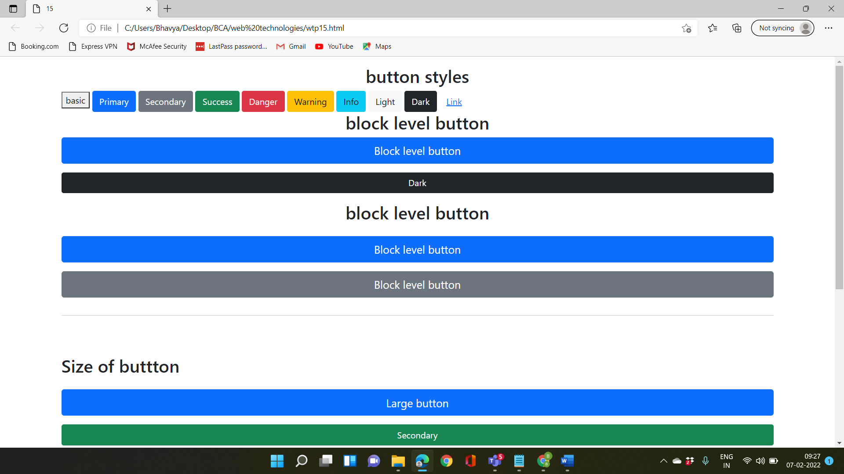

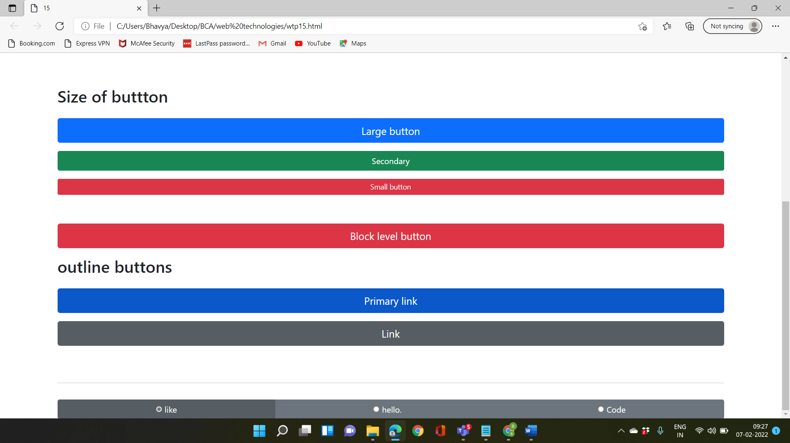

**Practicle-16**

**Objective:-create a web page containing to display the heading using jumbotron.**

**Source code:-**

<html>

<head>

<title>16</title> <meta charset="utf-8">

<meta name="viewport" content="width-device-width, initial-scale=1">

<link href="https://cdn.jsdelivr.net/npm/bootstrap@5.1.3/dist/css/bootstrap.min.css" rel="stylesheet" integrity="sha384

1BmE4kWBq781YhFldvKuhfTAU6auU8tT94WrHftjobrCEXSU10Boqy12QvZ6jIW3" crossorigin="anonymous"> <script src="https://cdn.jsdelivr.net/npm/bootstrap@5.1.3/dist/js/bootstrap.bundle.min.js"></script> font-family: "Times New Roman", Times, serif;

p.a {

font-family: "Times New Roman",Times, Serif;

}

p.b {

font-family: Arial, Helvetica, sans-serif;

}

</style>

<body background="C:\Users\Bhavya\Downloads\wood.jpg">

<div class="container mt-3">

<h1 style="background-color: #CD5C5C;"> <center>Headings</center></h1>

<font color="pink"><h1>h1. Bootstrap heading</h1>

<h2>h2. Bootstrap heading</h2>

<h3>h3. Bootstrap heading</h3>

<h4>h4. Bootstrap heading</h4>

<h5>h5. Bootstrap heading</h5>

<h6>h6. Bootstrap heading</h6>

<><br>

<h1 style="background-color: #CD5C5C;"> font family</h1>

<p class="a">This is a paragraph, shown in the Times New Roman font.</p>

<p class="b"> This is a paragraph, shown in the Arial font.</p>

</div>

</body>

</html>

**Output:-**

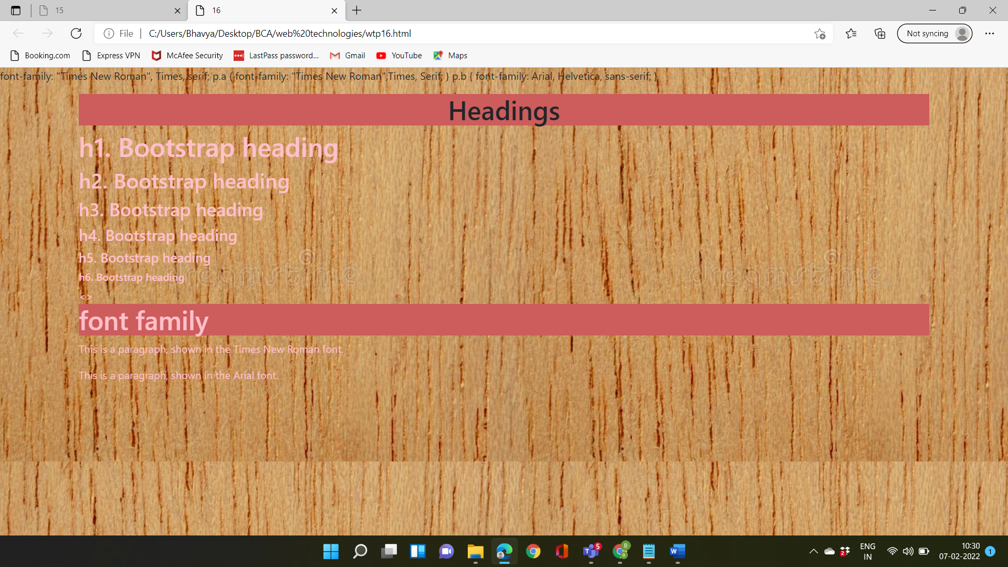

**Practicle-17**

**Objective:-create a web page containing to display the heading using jumbotron.**

**Source code:-**

<html>

<head>

<title>17</title>

<meta charset="utf-8">

<meta name="viewport" content="width-device-width, initial-scale=1">

<link href="https://cdn.jsdelivr.net/npm/bootstrap@5.1.3/dist/css/bootstrap.min.css" rel="stylesheet" integrity="sha384

1BmE4kWBq78iYhF1dvKuhfTAU6auU8tT94WrHftjDbrCEXSU10Boqy12QvZ6jIW3" crossorigin="anonymous"> <script src="https://cdn.jsdelivr.net/npm/bootstrap@5.1.3/dist/js/bootstrap.bundle.min.js"></script>

</head>

<body>

<div class="container">

<div class="jumbotron">

<h1>BOOTSTRAP </h1>

</div>

<p>Bootstrap is a free and open-source CSS framework directed at responsive, mobile-first front-end web development. It contains CSS and JavaScript-based design templates for typography, forms, buttons, navigation, and other interface components</p>

<p>CSS-Cascading Style Sheets is a style sheet language used for describing the presentation of a document written in a markup language such as HTML. CSS is a cornerstone technology of the World Wide Web, alongside HTML and JavaScript</p>

<p>HTML-The HyperText Markup Language, or HTML is the standard markup language for documents designed to be displayed in a web browser. It can be assisted by technologies such as Cascading Style Sheets and scripting languages such as JavaScript.</p>

</div>

</body> </html>

**Output:-**

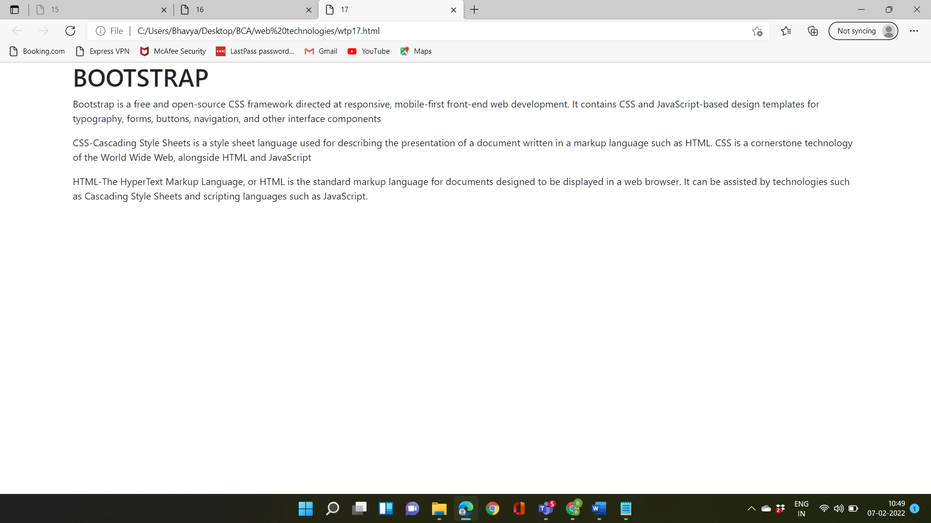

**Practicle-18**

**Objective:- Write a program to show the usage of inbuilt function and dialog boxes.**

**Source code:-**

<!DOCTYPE html>

<html>

<head></head>

<script type = "text/javascript">

function Warn() {alert ("This is a Alert Box!");

document.write ("Prompt window was Alert Box and shown by using function !");

} </script>

<style>

.button3 {

background-color: white;

color: black;

border: 2px solid #008CBA;} </style>

<body bgcolor="#5DADE2">

<h2>bhawya JavaScript</h2>

<button type="button"

onclick="document.getElementById('time').innerHTML = Date()">

Click me to display Date and Time.</button>

<p id="time"></p>

<h2>display?</h2>

<p>normal and laughing</p>

<p>In this case JavaScript changes the value of the src (source) attribute of an image.</p>

<button onclick="document.getElementById('myImage').src='C:\Users\Bhavya\Downloads\istockphoto-185099361-1024x1024.jpg'">of</button>

<img id="myImage" src="C:\Users\Bhavya\Downloads\istockphoto-185099361-1024x1024.jpg" style="width:100px">

<button onclick="document.getElementById('myImage').src='C:\Users\Bhavya\Downloads\light-bulb.jpg'">ON</button>

<center> <p>Click on Button </p>

<input type = "button" class="hov"value = "Click Me" onclick = "Warn();" /></body></center>

</body></html>

**Output:-**

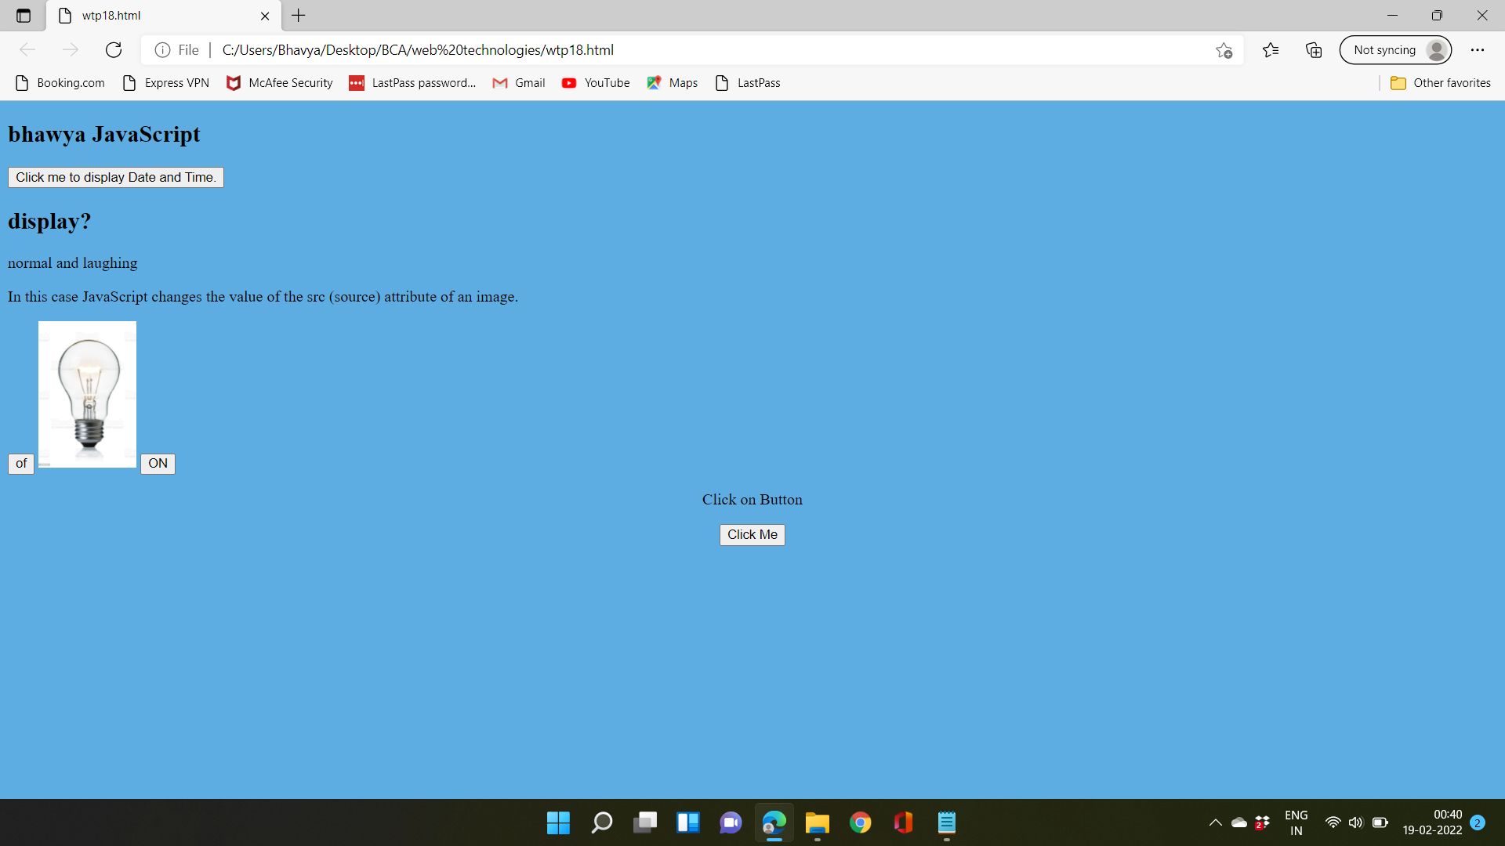

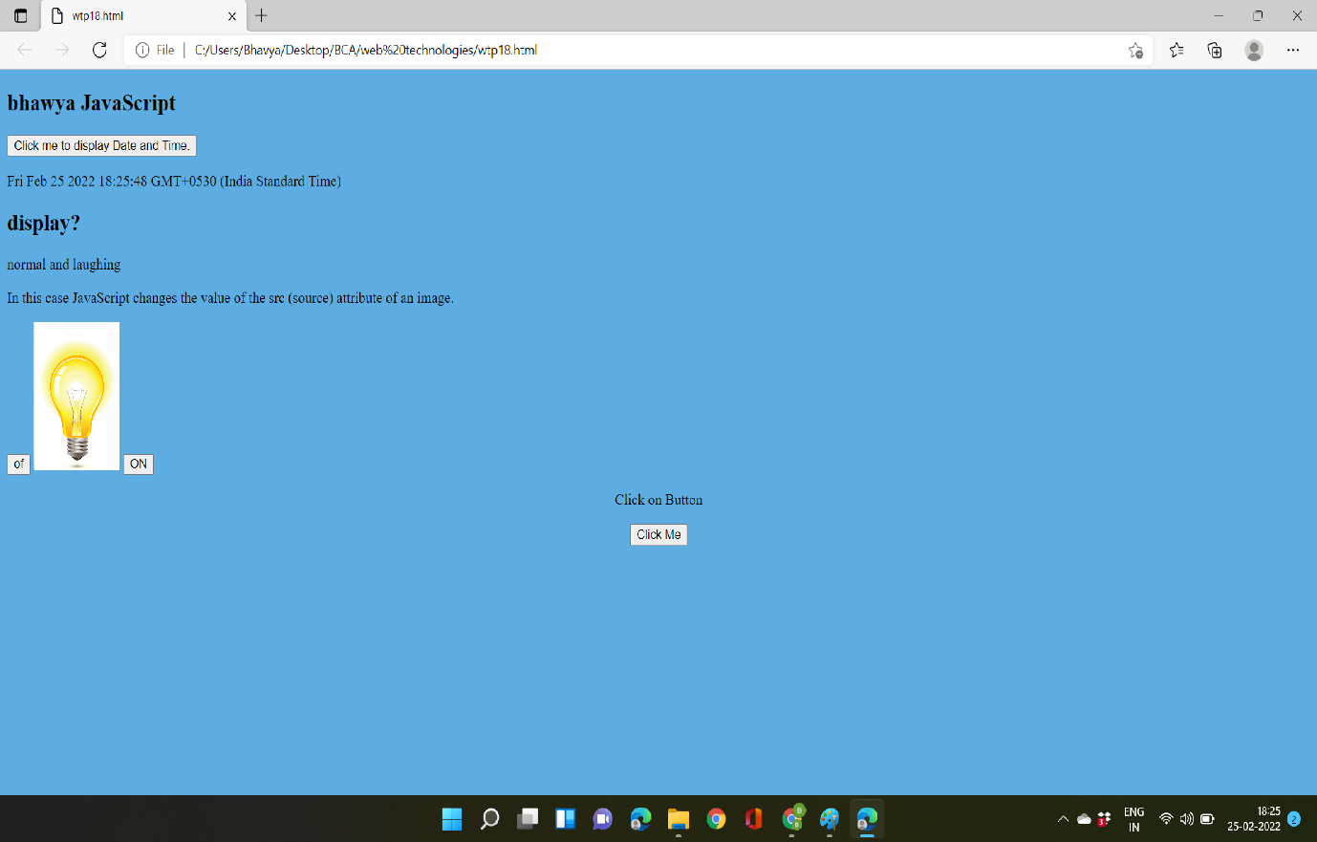

**Practicle-19**

**Objective:- Write a program to show the usage of alert box and confirm box.**

**Source code:-**

<html>

<head>

<script type = "text/javascript">

function Warn() {alert ("This is a Alert Box!");

document.write ("Prompt window was Alert Box and shown by using function !");

}</script>

<script>

function myFunction() {

confirm("Press a button!");

}</script>

<style>

.button3 {

background-color: rgb(255, 255, 255);

color: black;

border: 2px solid #008CBA;}

</style>

</head>

<body style="text-align: center;" bgcolor="lightgoldenrodyellow">

<p>Click on the Button </p>

<input type = "button" class="hov"value = "Click Me" onclick = "Warn();" /></body>

<h2><font color="coral" face="Algerian">The confirm() Method</h2>

<p>Click the button to display a confirm box.</p></font>

<button onclick="myFunction()">Try it</button>

</html>

**Output:-**

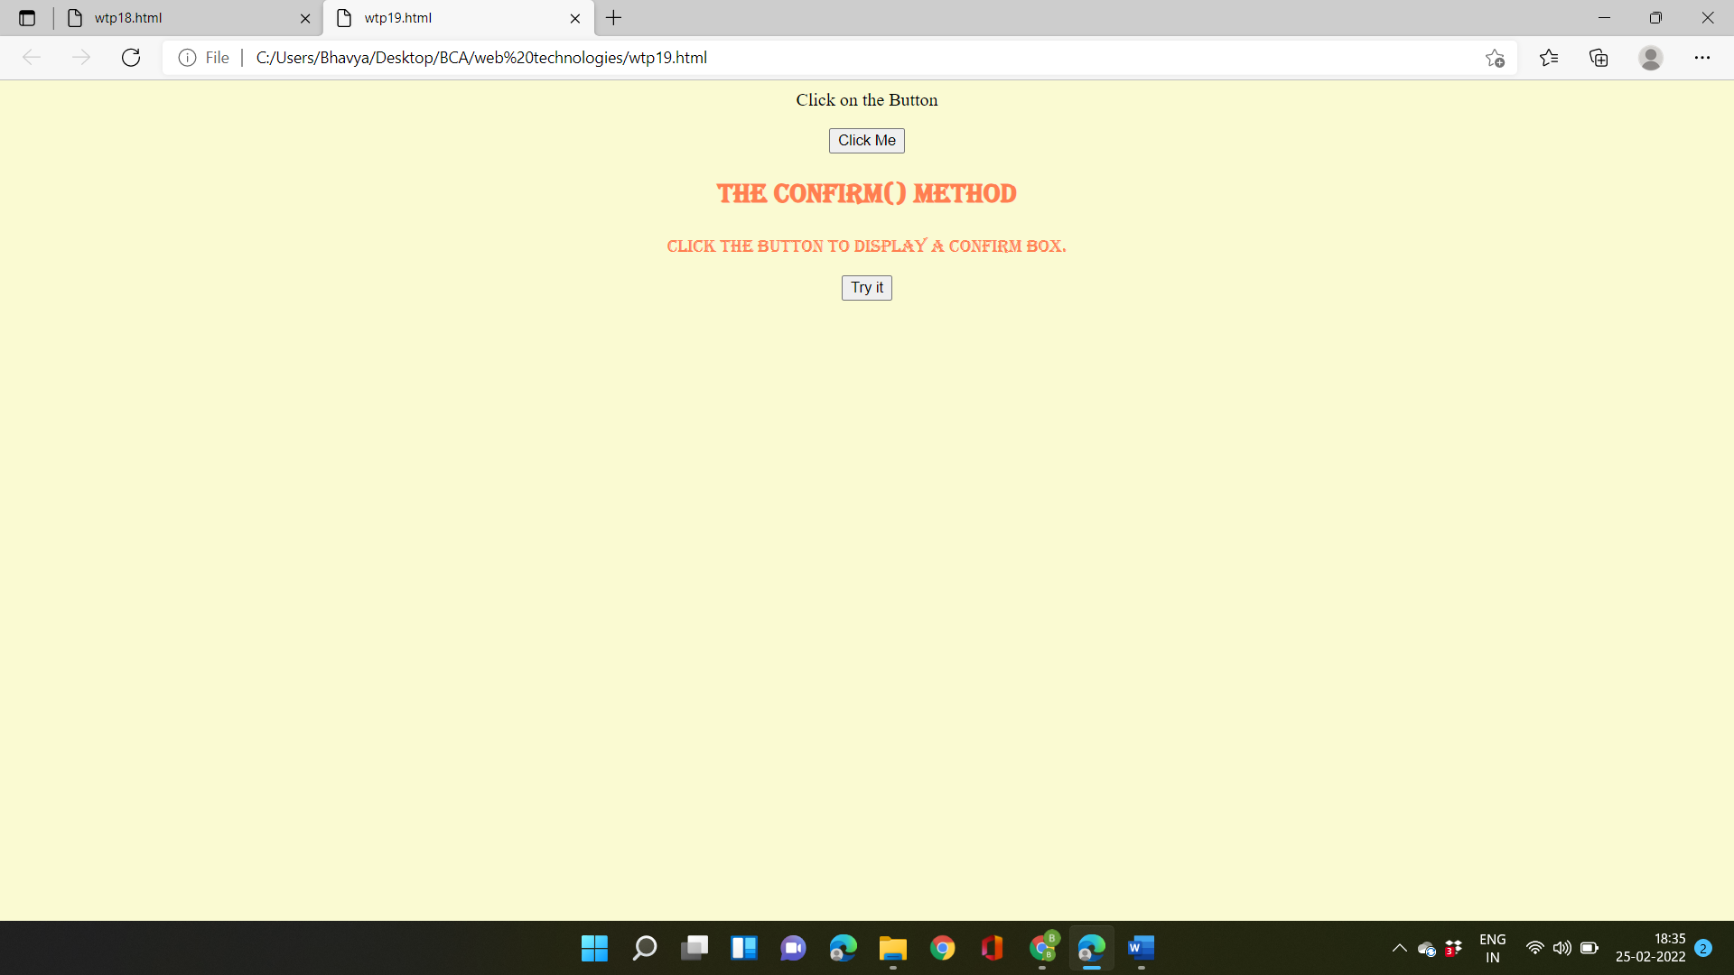

* When click on button “click me”.

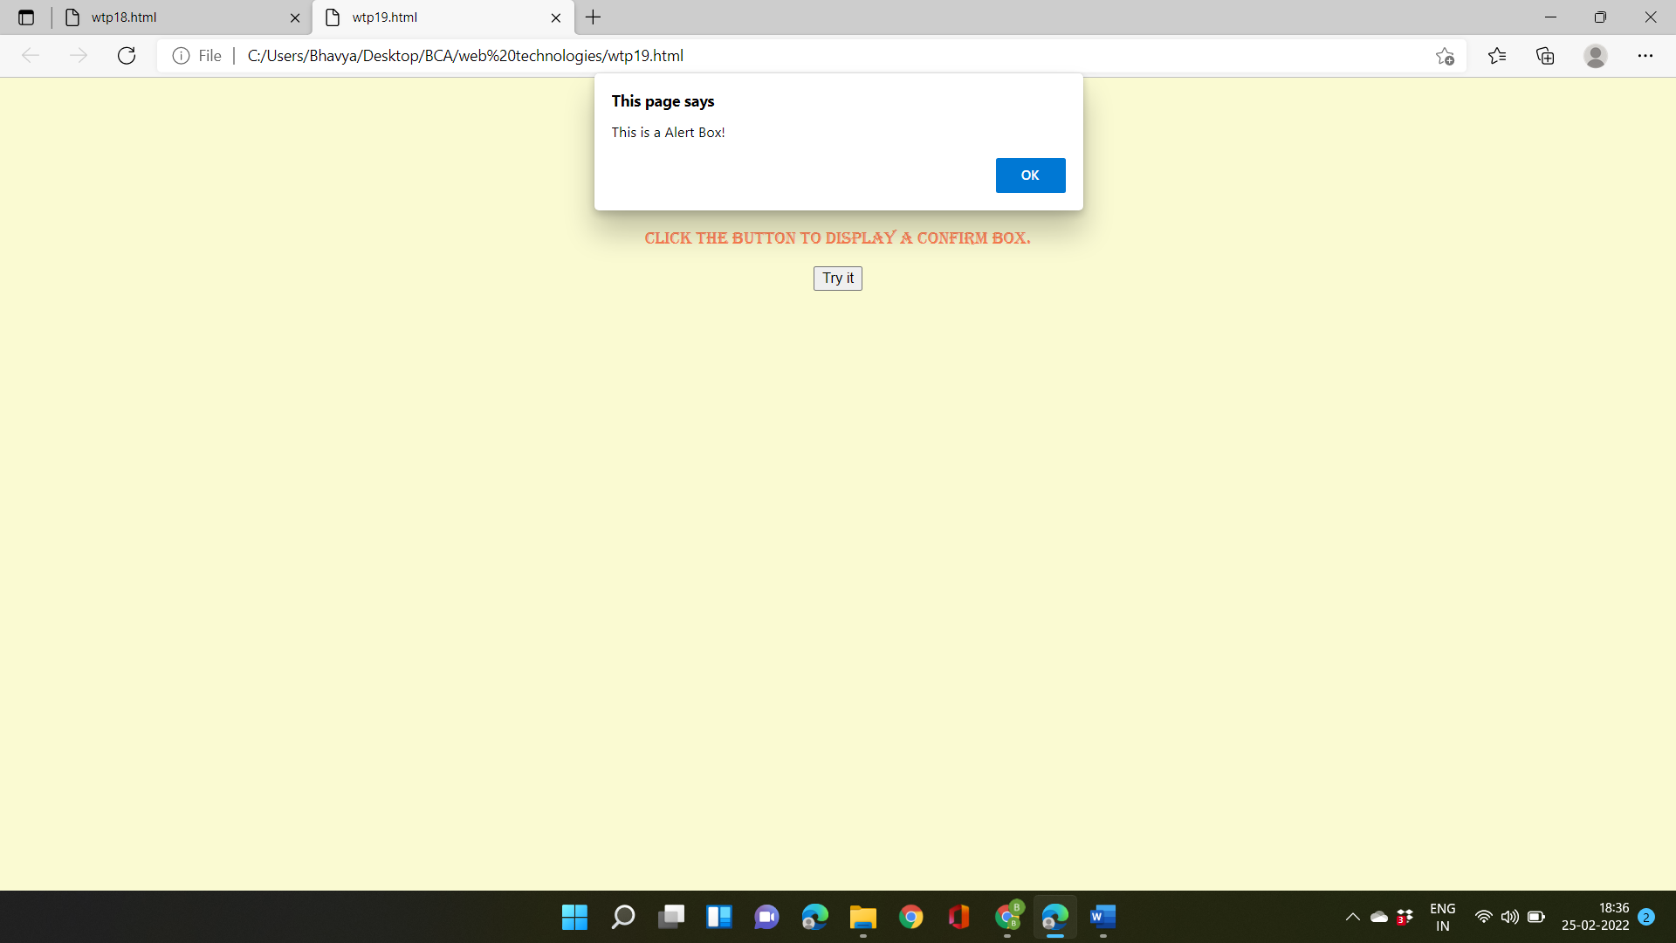

* When click on button “try it”.

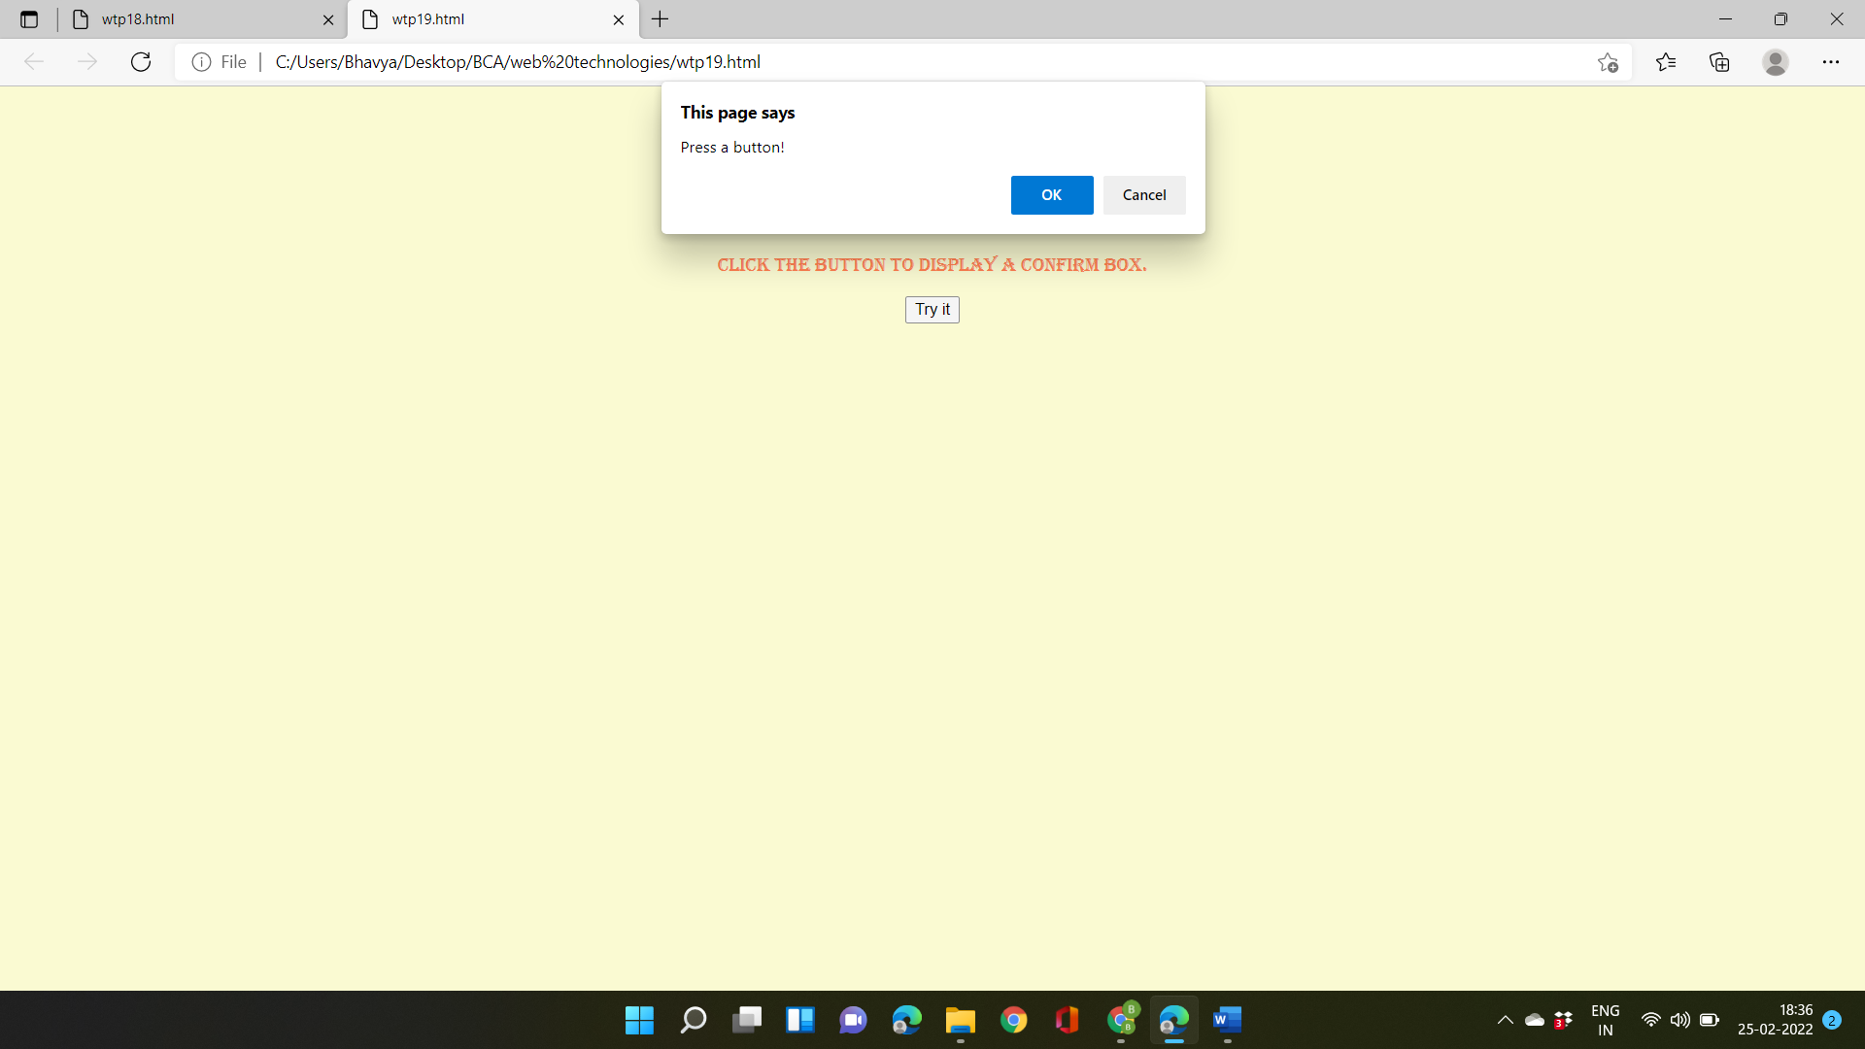

**Practicle-20**

**Objective:- Write a program to implement event handling using onclick, on mouse over and on mouse out events.**

**Source code:-**

<!DOCTYPE html>

<html lang="en">

<head>

<meta charset="UTF-8">

<meta http-equiv="X-UA-Compatible" content="IE=edge">

<meta name="viewport" content="width=device-width, initial-scale=1.0">

<title>Document</title>

</head>

<body bgcolor="paleturquoise">

<img src="C:\Users\Bhavya\Downloads\stock-photo-142984111.jpg" alt="9.jpg" id="img" width="200"><br>

<button id="hide">hide the image</button>

<button id="show">show the image</button>

<h1 id="text">Mouse Over</h1>

<script type="text/JavaScript">

let image=document.getElementById("img")

let hide=document.getElementById("hide")

let show=document.getElementById("show")

let text=document.getElementById("text")

hide.onclick=function(){

image.style.display='none'

}

show.onclick=function() {

image.style.display='block'

}

text.onmouseout=function(){

text.innerHTML='HELLO!!!'

}

text.onmouseover=function(){

text.innerHTML='Mouse Over'

}</script>

</body>

</html>

**Output:-**

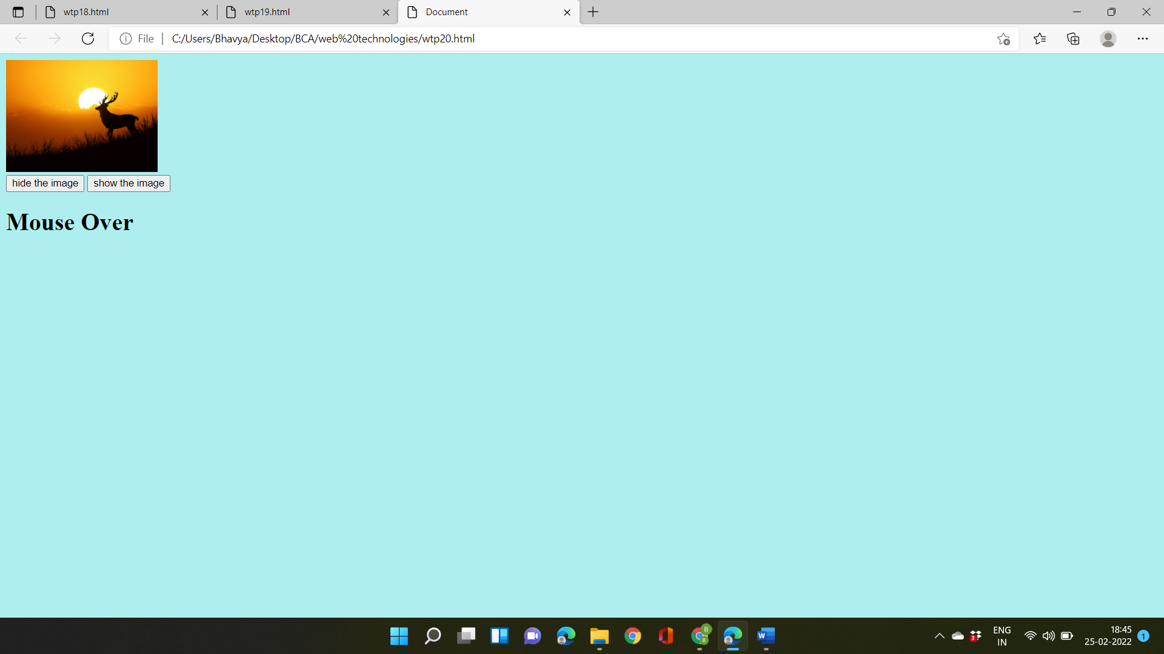

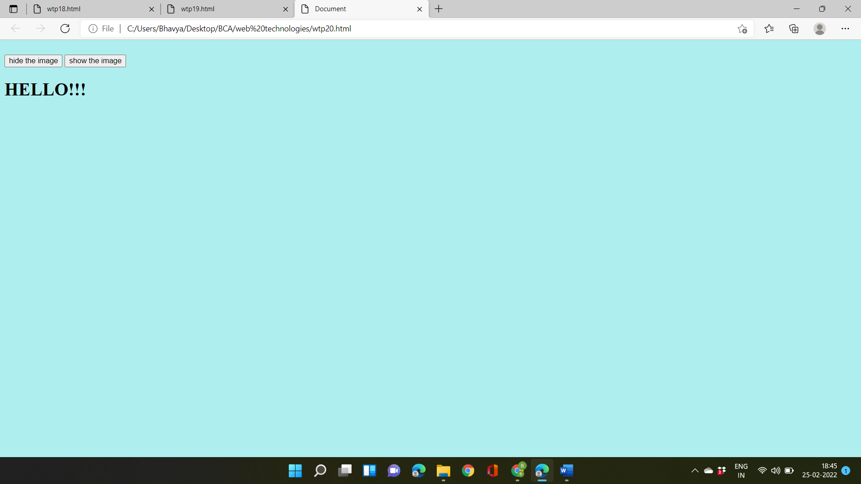

**Practicle-21**

**Objective:- Write a program to show the usage of all the date,math and string object functions.**

**Source code:-**

<!DOCTYPE html>

<html>

<body bgcolor="lawngreen"><font color="deeppink" face="algerian">

<h2>JavaScript Math Constants</h2>

<p id="demo"></p>

<script>

document.getElementById("demo").innerHTML =

"<p><b>Math.E:</b> " + Math.E + "</p>" +

"<p><b>Math.PI:</b> " + Math.PI + "</p>" +

"<p><b>Math.SQRT2:</b> " + Math.SQRT2 + "</p>" +

"<p><b>Math.SQRT1_2:</b> " + Math.SQRT1_2 + "</p>" +

"<p><b>Math.LN2:</b> " + Math.LN2 + "</p>" +

"<p><b>Math.LN10:</b> " + Math.LN10 + "</p>" +

"<p><b>Math.LOG2E:</b> " + Math.LOG2E + "</p>" +

"<p><b>Math.Log10E:</b> " + Math.LOG10E + "</p>";

</script>

<h2>JavaScript Math.pow()</h2>

<p>Math.pow(x,y) returns the value of x=7 to the power of y=3:</p>

<p id="demoo"></p>

<script>

document.getElementById("demoo").innerHTML = Math.pow(7,3);

</script>

<h2>JavaScript String</h2>

<p id="demo1"></p>

<font size="10"><script>

let text = "BHAWYA GARG"; // String written inside quotes

document.getElementById("demo1").innerHTML = text;

</script></font>

<button type="button"

onclick="document.getElementById('time').innerHTML = Date()">

Click me to display Date and Time</button>

<p id="time"></p></font>

</body>

</html>

**Output:-**

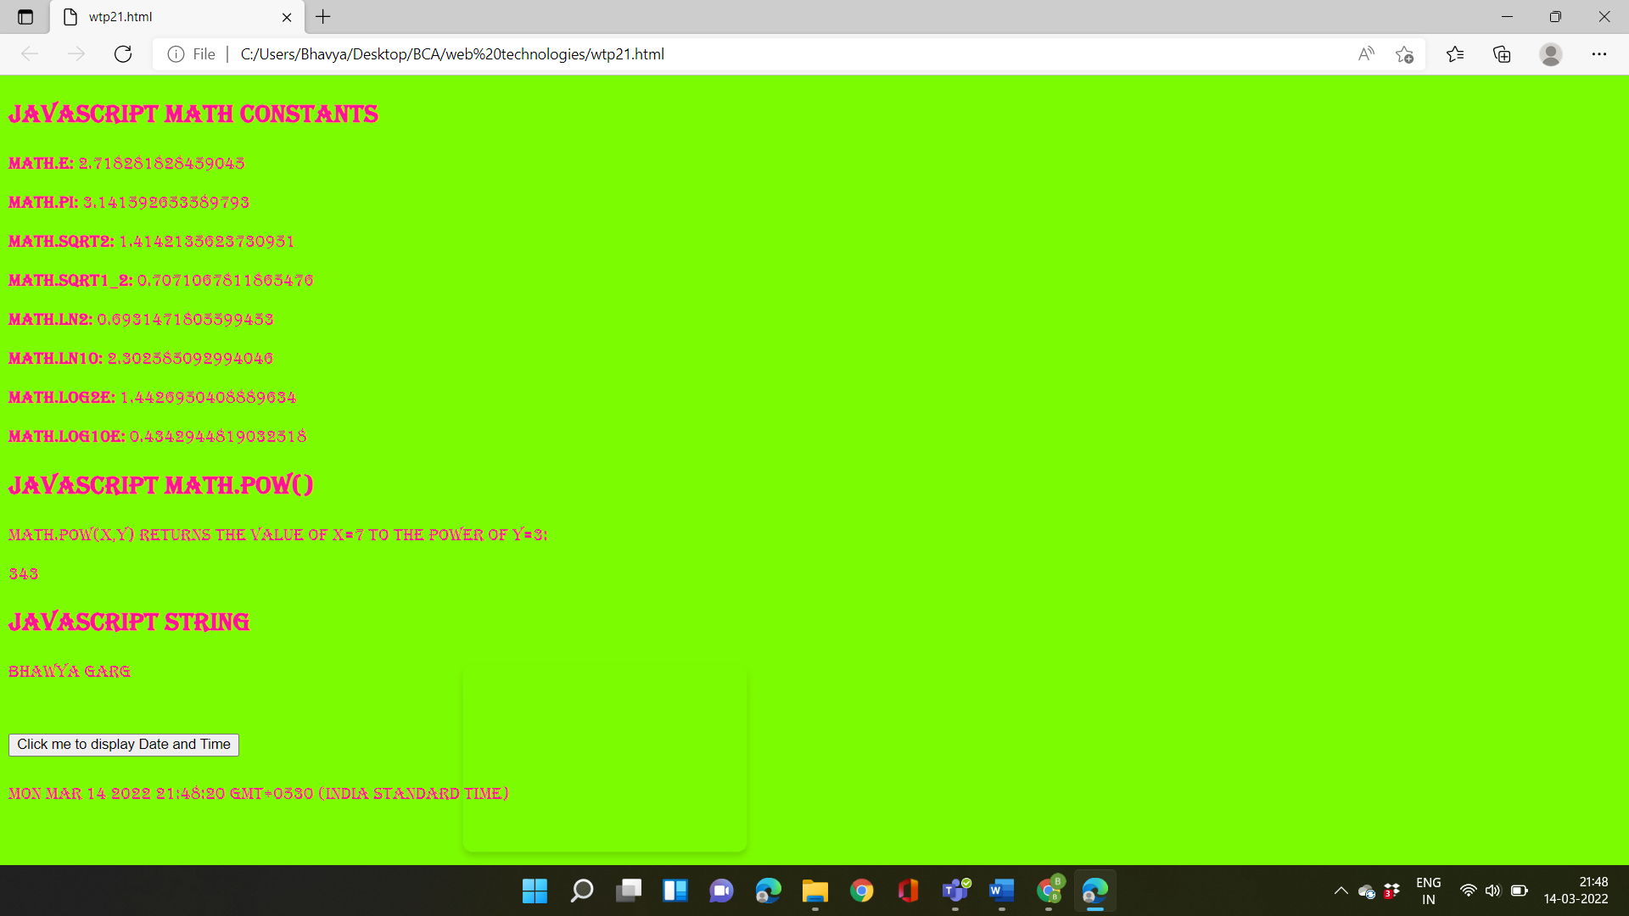

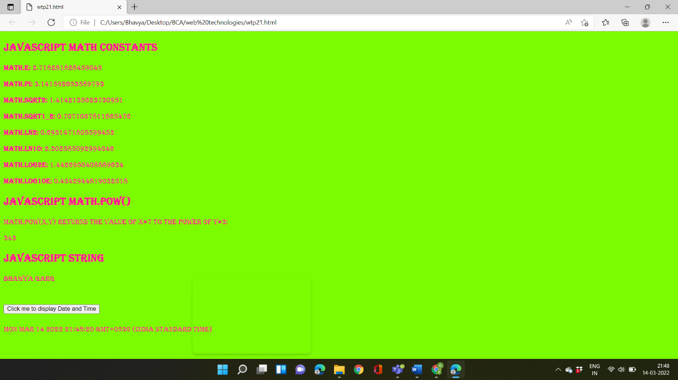

**Practicle-22**

**Objective:- WAP to display the bookstore details in XML with CSS and internal DTD.**

**Source code:-**

<bookstore>

<books >

<comic_book>Spider Man</comic_book>

<author>Stan Lee</author>

<pages >300</pages>

<technical_book> Let us c</technical_book>

<author>Yashwant</author >|

<pages>300</pages >

<legends_book>Mahatama Gandhi</legends_book>

<author>Ramchandra Guha</author>

<pages>400</pages>

<Industrial_book> Relations</Industrial_book>

<author > Monal Arora</author>

<pages>300</pages >

</books>

</bookstore>

**Output:-**

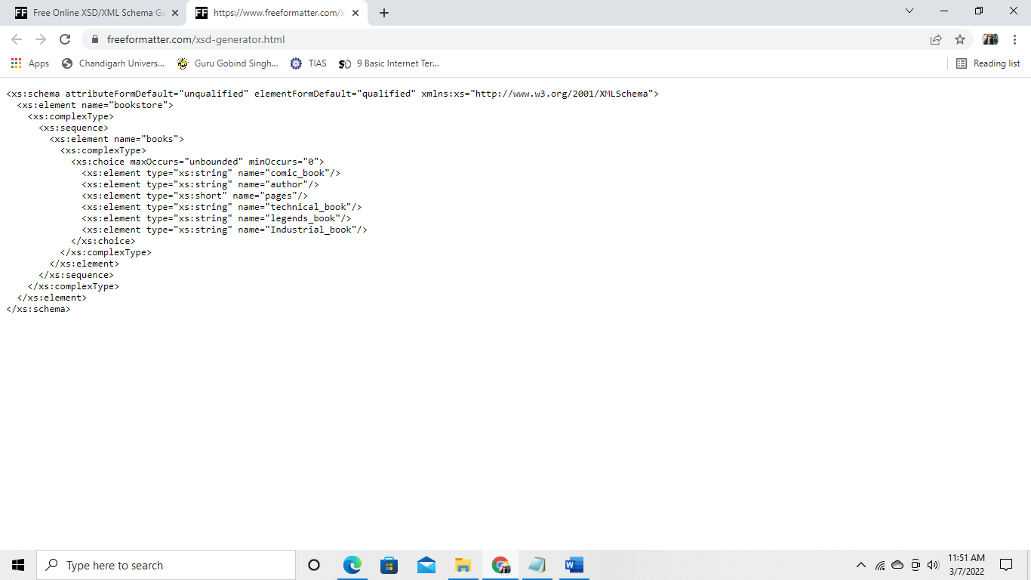



**Practicle-23**

**Objective:- WAP to display the bookstore details in XML with CSS and internal DTD.**

**Objective:- WAP to format the Teacher details in XML with CSS using external DTD.**

**Source code:-**

<teachers >

<name>Teachers of BCA Department</name>

<subject name="Web_Technology"></subject>

<teacher_name>DR. Sonal Dahiya</teacher_name>

<salary> 30000</salary>

<subject name="FCIT"> </subject>

<teacher_name> DR. Deepak Sonkar </teacher_name>

<salary> 50000</salary>

<subject name="Technical Communication"></subject>

<teacher_name>Ms. Sania</teacher_name>

<salary> 30000</salary>

<subject name="Discrete Mathematics"> </subject>

<teacher_name> Mr. Raju</teacher_name>

<salary> 20000</salary>

<subject name="Programming using C Language"></subject>

<teacher_name>Mr. Ajay Dureja</teacher_name>

<salary> 35000</salary>

</teachers >

**Output:-**

